Instructions for the use of the e-JN information system: TENDERERS
e-JN system version 4.12.1.0. and subsequent

Ljubljana, June 2026

Table of contents

Instructions for the use of the e-JN information system: TENDERERS 1
1. INTRODUCTION 4
1.1. What are the advantages of registering in the e-JN system? 4
2. USER ROLES 4
2.1. How to register in the e-JN system? 5
2.1.1. Registration of a legal representative of a company in the Republic of Slovenia 5
2.1.2. Registration of an authorised person of a legal entity 5
2.1.3. Registration of a sole trader 6
2.1.4. Registration of a natural person 6
2.1.5. Registration of an authorised person of a natural person or a sole trader 7
2.1.6. Registration of a company with head office outside the Republic of Slovenia 7
2.1.7. Registration of a company with head office in the Republic of Slovenia with foreign ownership or authorized person 8
3. PUBLIC PROCUREMENTS 9
3.1. How do I find current public procurements and where do I find invitations? 9
3.2. How can I participate in a public procurement? 11
4. TENDER 12
4.1. How do I prepare and submit my tender? 12
4.2. What if I do not have the right to submit the tender? 12
4.3. Can I submit a new version of the tender? 12
4.4. Can I withdraw the tender that I have submitted? 13
4.5. What if I change my mind and want to submit the withdrawn tender again? 13
4.6. What if contracting authority changed the pro-forma invoice in e-JN system? 13
5. OPENING OF TENDERS 14
5.1. Where can I see who has submitted the tender for the public procurement? 14
6. BRIEF DESCRIPTION OF FUNCTIONALITIES OF THE e-JN SYSTEM 15
6.1. My e-JN 16
6.2. Public contracts with invitation 16
6.2.1. List of invitations 16
6.3. Tender 18
6.3.1. List of tenders 18
6.3.2. Preparation and submission of a tender 18
6.3.3. Review of the basic data of the tender 21
6.3.4. Changing the tender 22
6.3.5. Withdrawal of the tender 24
6.3.6. Re-submission of the tender 24
6.3.7. Review of the minutes on the opening of tenders 25
6.3.8. Submission of the tender with or without lots 25
6.3.9. Submission of the tender with variants (variant tenders) 26
6.3.10. Submission of a tender in the case of auction 27
6.3.11. Invitation to negotiations 29
6.3.12. Invitation to supplement the request to participate/tender 30
6.4. Uploading supporting documents 32
7. E-AUCTIONS 35
7.1. Functionality of the e-Auctions 35
7.2. Participation in the e-Auction 38
7.2.1. Actions during the implementation of the electronic auction 41
7.2.2. Explanation of individual fields and symbols displayed on the screen of the auction table 48
7.3. Completed e-Auction 50
8. DYNAMIC PURCHASING SYSTEM 51
8.1. Participation in the DPS 51
8.2. Subsequent application to DPS procedures 53
8.3. Request your qualification and specific procurements 53
8.3.1. Participation in specific procurements of the DPS (second phase) 54
8.4. Verification of qualification to participate in the DPS 54
9. INFORMATION AND NOTIFICATION CENTER 55
9.1. Notification centre 56
10. FAQ 58

INTRODUCTION
The e-JN information system (hereinafter: the e-JN system) is intended to support public procurement procedures and the electronic submission of requests to participate or tenders.

What are the advantages of registering in the e-JN system?
- Request to participate in the currently published public procurements made public
- Receipt of invitations by the Contracting Authority to participate in public procurements that are not made public
- Preparation of requests to participate or tenders for public procurement
- Electronic submission of requests to participate or tenders
- Review of the minutes on the opening of tenders following a public opening
- Submission of tenders and participation in electronic auctions
- Submission of tenders in negotiations
- Submission of supplements
- Implementation of electronic auctions

USER ROLES
A registered user of an economic operator/tenderer may dispose of a diverse selection of user rights, which they may implement through the user roles allocated to them in the e-JN system. Considering their situation, a user may register as:
- Legal representative of a legal entity: the first login for a legal entity with a head office in the Republic of Slovenia may only be carried out by the legal entity’s legal representative who was entered in the Digital Certificate Record managed by the AJPES.
- Authorised person of a legal entity: once the legal entity is registered in the e-JN system, a random number of authorised people may be registered to work with the relevant legal entity. The legal entity’s legal representative or a person authorised to manage the rights within the relevant legal entity allocates the rights to the authorised person. The authorised people may thus be employed by the legal entity or they may be external people authorised to work with the relevant legal entity by the legal representative.
The legal representative allocates to the legal entity’s authorised person one or more of the rights provided below:
  - Signatory: the signatory’s right enables an entry, a signature and a submission of a tender.
  - Legal representative: this right enables management of users, code lists and parameters within the selected organisation, the entry, signature and the submission of a tender.
  - Administrator: this right enables the entry of tenders, although not the signature or the submission of tenders.
  - Holder and administrator of rights: this right enables management of users, code lists and parameters within the selected organisation.
- Sole trader: an entrepreneur who is a natural person and independently performs a gainful activity on the market and is registered in the Slovenian Business Register (PRS) is registered with this user role.
- Natural person: a natural person functioning as a tenderer on their own behalf as a natural person and are not a sole trader can be registered in the e-JN system with this user role. This category also includes supplementary activities at the farm, self-employed professionals in culture, freelance journalists and other similar freelance professions.
- Authorised person of a natural person or a sole trader: a natural person or a sole trader may register a random number of authorised people to work with the relevant legal entity. An authorised person is a person who is authorised by a natural person or a sole trader to carry out services in the e-JN system on their behalf. The authorised person must submit a printout of their authorisation to the administrator.
- Company with its head office outside the Republic of Slovenia: the companies with head offices outside the Republic of Slovenia must enter all registration data in the form manually and then submit the signed and printed form to the administrator.
- Company with its head office in the Republic of Slovenia with foreign ownership or authorized person: Registration to the e-JN information system with this user role is made by the owner of a company whose registered seat is in Republic of Slovenia if the owner is not a Slovene citizen or is made by an authorised representative of said company if he/she is a Slovene citizen.

How to register in the e-JN system?

Registration of a legal representative of a company in the Republic of Slovenia
A digital certificate is required for registration.
Attention! Choose this option only if you are a legal representative of a company in the Republic of Slovenia and your digital certificate is entered in the Digital Certificate Record (EDP) managed by the AJPES. Otherwise, you will be unable to apply for the rights (step 1.6 below).
Registration procedure:
- Submit an electronic application for registration of a legal representative.
  - Go to "URL address".
  - Click the "Register" button on the icon, "Are you a tenderer?"
  - Log in to your SI-PASS account.
  - After successful login to SI-PASS, system e-JN will ask you to agree to the general terms and conditions for use of the e-JN system. If you agree with them, tick the box and click “Confirm”.
  - After confirming general terms and conditions you will be redirected to the registration application. Choose "Legal representative of a legal entity".
  - Enter the registration number of your company, then click "Search".
  - Verify the accuracy of the data displayed, and if you agree with them, click "Register me".
- After successful registration, you will be automatically registered and redirected to My e-JN, where you can start using the application.

Registration of an authorised person of a legal entity
A digital certificate is required for registration.
Registration procedure:
- Submit an electronic application for registration of an authorised person of a legal entity.
  - Go to "URL address".
  - Click the "Register" button on the icon, "Are you a tenderer?"
  - Log in to your SI-PASS account.
  - After successful login to SI-PASS, system e-JN will ask you to agree to the general terms and conditions for use of the e-JN system. If you agree with them, tick the box and click “Confirm”.
  - After confirming general terms and conditions you will be redirected to the registration application. Choose "Authorised person of a legal entity".
  - Enter the registration number of your company, then click "Search".
  - Verify the accuracy of the data displayed, and if you agree with them, click "Apply for rights".
- After successful confirmation of your rights by the legal representative or the holder and administrator of rights, you will receive a notification by e-mail and then you can start using the application.

Registration of a sole trader
A digital certificate is required for registration.
Attention! Choose this option only if you are a registered sole trader. Otherwise, you will be unable to apply for the rights (step 1.5 below).
Registration procedure:
- Submit an electronic application for registration of a sole trader.
  - Go to "URL address".
  - Click the "Register" button on the icon, "Are you a tenderer?"
  - Log in to your SI-PASS account.
  - After successful login to SI-PASS, system e-JN will ask you to agree to the general terms and conditions for use of the e-JN system. If you agree with them, tick the box and click “Confirm”.
  - After confirming general terms and conditions you will be redirected to the registration application. Choose "Sole trader".
  - Verify the accuracy of the data displayed, and if you agree with them, click "Register me".
- After successful registration, you will be automatically registered and redirected to My e-JN, where you can start using the application.

Registration of a natural person
A digital certificate is required for registration.
Registration procedure:
- Submit an electronic application for registration of a natural person.
  - Go to "URL address".
  - Click the "Register" button on the icon, "Are you a tenderer?"
  - Log in to your SI-PASS account.
  - After successful login to SI-PASS, system e-JN will ask you to agree to the general terms and conditions for use of the e-JN system. If you agree with them, tick the box and click “Confirm”.
  - After confirming general terms and conditions you will be redirected to the registration application. Choose "Natural person".
  - Enter your address and phone number.
  - Verify the accuracy of the data displayed, and if you agree with them, click "Register me".
- After successful registration, you will be automatically registered and redirected to My e-JN, where you can start using the application.

Registration of an authorised person of a natural person or a sole trader
A digital certificate is required for registration.
Registration procedure:
- Submit an electronic application for registration of an authorised person of a natural person or a sole trader.
  - Go to "URL address".
  - Click the "Register" button on the icon, "Are you a tenderer?"
  - Log in to your SI-PASS account.
  - After successful login to SI-PASS, system e-JN will ask you to agree to the general terms and conditions for use of the e-JN system. If you agree with them, tick the box and click “Confirm”.
  - After confirming general terms and conditions you will be redirected to the registration application. Choose "Authorised person of a natural person or a sole trader".
  - Enter the VAT ID number of the person you wish to represent and then click "Search".
  - Complete the data on the authoriser (name and surname, e-mail, address, phone number).
  - Complete your missing data (e-mail, address, phone number).
  - Verify the accuracy of the data displayed, and if you agree with them, first click on the right button "Request rights".
  - Then click on the left button “Download PDF”. After downloading the pdf authorisation, print it out, fill it out and send it to gp.mju@gov.si after it was signed by the authoriser.
- After successful confirmation of your rights, you will receive a notification by e-mail and then you can start using the application.

Registration of a company with head office outside the Republic of Slovenia
A digital certificate is required for registration.
Registration procedure:
- Submit an electronic application for registration of a company with head office outside the Republic of Slovenia.
  - Go to "URL address".
  - Click the "Register" button on the icon, "Are you a tenderer?"
  - Log in to your SI-PASS account.
  - After successful login to SI-PASS, system e-JN will ask you to agree to the general terms and conditions for use of the e-JN system. If you agree with them, tick the box and click “Confirm”.
  - After confirming general terms and conditions you will be redirected to the registration application. Choose "Company with its head office outside the Republic of Slovenia".
  - Enter the company identifier and then click "Search".
  - Enter your data (name and surname, e-mail, address, phone number).
  - Enter company data (name and address).
  - Verify the accuracy of the data displayed, and if you agree with them, first click on the right button "Request rights".
  - Then click on the left button “Download PDF”. After downloading the pdf authorisation, print it out, fill it out , sign it and then send it to gp.mju@gov.si.
- After successful confirmation of your rights, you will receive a notification by e-mail and then you can start using the application.
Detailed instructions for registration of a company with head office outside the Republic of Slovenia are available at More information tenderer, Registration to e-JN information system for a “Company registered outside Slovenia”.

Registration of a company with head office in the Republic of Slovenia with foreign ownership or authorized person
A digital certificate is required for registration.
Registration procedure:
- Submit an electronic application for registration of a company with foreign ownership or authorized person.
  - Go to "URL address".
  - Click the "Register" button on the icon, "Are you a tenderer?"
  - Log in to your SI-PASS account.
  - After successful login to SI-PASS, system e-JN will ask you to agree to the general terms and conditions for use of the e-JN system. If you agree with them, tick the box and click “Confirm”.
  - After confirming general terms and conditions you will be redirected to the registration application. Choose " Company with foreign ownership or authorized person ".
  - Enter the registration number of the organization you wish to represent and then click "Search".
  - Complete your missing data (e-mail, address, phone number).
  - Verify the accuracy of the data displayed, and if you agree with them, first click on the right button "Request rights".
  - Then click on the left button “Download PDF”. After downloading the pdf authorisation, print it out, fill it out and send it to gp.mju@gov.si after it was signed by the legal representative.
- After successful confirmation of your rights, you will receive a notification by e-mail and then you can start using the application.

PUBLIC PROCUREMENTS

How do I find current public procurements and where do I find invitations?
It is possible to access and review the current public procurements in several ways:
- through the Public Procurement Portal
- through the entry page, e-JN electronic public procurement portal, by examining Current public procurements
- If you are signed in the e-JN system, you can click on "Current public procurements"
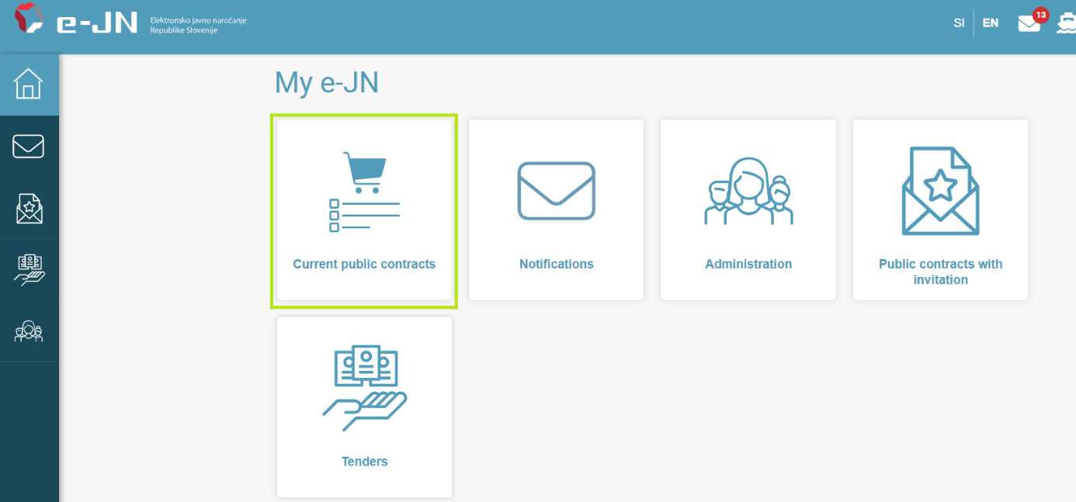
- »Current public procurement« icon

Invitations to participate in public procurements that are not published can be accessed as follows:
- A contracting authority invites you to participate by e-mail and refers you to examine the invitations.
- You register in the e-JN system and click on "Public contracts with invitation". A list of invitations is displayed on your desktop.
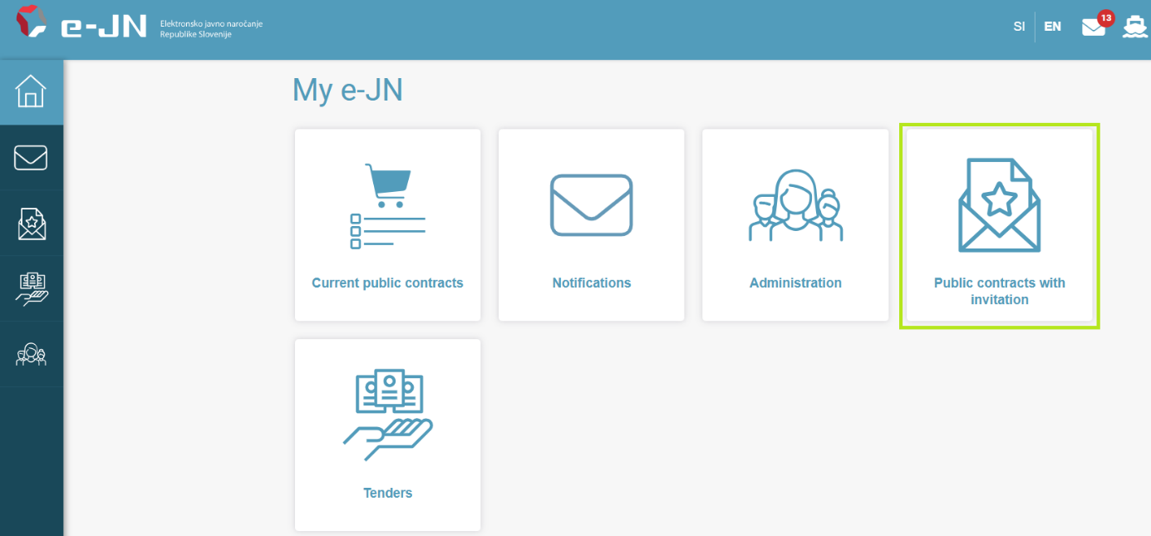
- »Public contracts with invitation« icon

 The e-JN system allows contracting authorities to prepare below-national threshold procurement in two ways, namely below-national threshold procurement without prior publication in e-JN system or below-national threshold procurement with prior publication in e-JN system.
If the contracting authority selects the option “Below-national threshold procurement without prior publication in e-JN”, the tenderers, whom the contracting authority has invited to participate in this contract, will receive an email with an invitation to participate.
If the contracting authority selects the option “Below-national threshold procurement with prior publication in e-JN system”, this contract is visible under "Current public contracts". In this case, tenderers who have (possibly) been invited by the contracting authority to submit a tender, as well as tenderers who have not been invited by the contracting authority, can participate in this public contract, as this contract is accessible to everyone through the e-JN system under "Current public contracts". If the tender wishes to participate in this public contract (and has not been invited by the contracting authority or has not received an email about participation), he can participate via the option "Current public contracts". On the page with basic data of the public contract, the section “Documentation” is additionally displayed. Instead of the "Participate in public contract" button, the "I am interested" button is displayed.
By clicking on the "I am interested" button, tenderers can be invited to participate in this public contract. If you are already logged in to the e-JN system and have not yet been invited to participate in this public contract, you will be invited to participate when you click on the button. You will be redirected to a page with basic public contract information (contract details), documentation, a section for asking questions and the "Participate in public contract" button. You can now also access this page via the "Public contracts with invitation" icon.
If you have already been invited to the public contract (you have received an email about participating in the public contract), then by clicking on the button, you will be redirected to the tender preparation page.
If there is no "Participate in public contract" or "I am interested" button on the right, the deadline for submitting applications or tenders has already passed and participation is no longer possible.

 A video presentation, how to find current public procurements.

How can I participate in a public procurement?
If you wish to participate in a public procurement, which is published under "Current public procurements":
- Find the public procurement in which you wish to participate in the table of "Current public procurements" and click on it.
- The page with basic information about the public procurement (procurement details) will open, including a link to the public procurement portal.
- Click on the "Participate in public procurement" button on the right hand side.
- If you are already signed into the e-JN system, the page for drafting request to participate/tender will open (see 6.3.2).
- If you are not signed into the e-JN system, you must sign in first.
If you wish to participate in a public procurement with an invitation:
- Click on the invitation in the table with invitations or click on the link that you received to your e-mail address via ejn@gov.si.
- The page with basic information about the public procurement (procurement details) and documentation will open.
- Click on the "Participate in public procurement" button on the right hand side.
- The page for the preparation of the tender will open.
If there is no "Participate in public procurement" button on the right hand side, the deadline for the submission of requests to participate or tenders has expired and participation is no longer possible.
A video presentation of participation in a public procurement.

TENDER

How do I prepare and submit my tender?
- When selecting the option, "Participate in public procurement", the page for the preparation of the tender opens.
- Enter the data and add the documents (see 6.3.2).
- Save the data or submit the tender if you have the right to submit the tender.
A video presentation of preparation and submission of the tender.
The preparation of the tender (data entry and addition of documents) can be performed by only one user at a time. In the case of simultaneous editing of the tender by several users, the e-JN system does not guarantee the correctness of the entered data.

What if I do not have the right to submit the tender?
- The person who has the right to submit the tender selects the tender you prepared from the list of tenders (see 6.3.3) and clicks on it.
- A page with an overview of the tender will open.
- They click on the tender to see detailed data and select the "Submit the tender" button.

Can I submit a new version of the tender?
If you have already submitted one version of the tender, you may submit a new version until the deadline for the submission of tenders. This can be done as follows:
- Find the tender from the list of tenders and click on it.
- A page with an overview of the basic data of the tender will open.
- Click on the "New version of the tender" button.
- A new version of the tender will open, which includes all data of the submitted version.
- You can change the data at this point and add or remove documents.
- Save and submit this version of the tender in the same way as when submitting the first version.
- The previously submitted offer is considered as submitted until a new version is submitted. Once the new version of the tender is submitted, previously submitted offer is repealed.
If there is no "New version of the tender" button on the right hand side, the deadline for the submission of tenders has expired and submission is no longer possible.
A video presentation of a new version of the tender.

Can I withdraw the tender that I have submitted?
Yes, you can withdraw the tender until the deadline for the submission of tenders. This can be done as follows:
- Find the tender from the list of tenders and click on it.
- A page with an overview of the basic data of the tender will open.
- Click on the "Withdraw the tender" button on the left hand side.
- The submission has been withdrawn.
If there is no "Withdraw the tender" button on the left hand side, the deadline for the withdrawal of tenders has expired and the withdrawal is no longer possible.

What if I change my mind and want to submit the withdrawn tender again?
You can submit the withdrawn tender again until the deadline for the submission of tenders. This can be done as follows:
- Find the withdrawn tender from the list of tenders and click on it.
- A page with an overview of the basic data of the tender will open.
- Click on the "Cancel withdrawal of participation" button on the left hand side.
- The data of the withdrawn tender will be displayed, which you can change.
- Save and submit the tender in the same way as when submitting the first tender.
- The tender has been resubmitted.
If there is no "Cancel withdrawal of participation" button on the left hand side, the deadline for the submission of tenders has expired and submission is no longer possible.

What if contracting authority changed the pro-forma invoice in e-JN system?
If you have already submitted a tender and a change of the public procurement with change of pro-forma invoice has been published, you will be notified by a notice in the tender overview. To avoid errors or incorrect display of tenders, we suggest submitting a new version of the tender. This can be done by the deadline of tender submission.

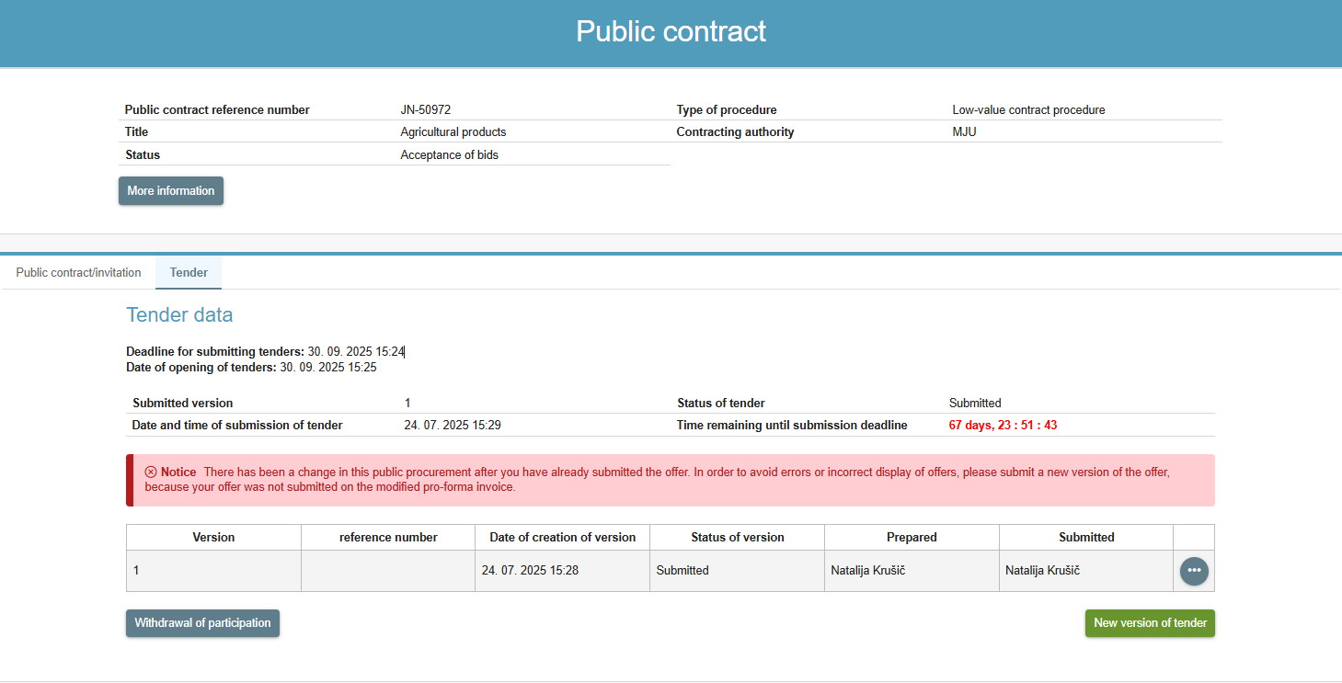
- Change of public procurement with change of pro-forma invoice

In the case your tender was already in preparation and contracting authority has made a modification in the pro-forma invoice in the e-JN system, the tender will be automatically cancelled as soon as the modification to the pro-forma invoice is published. In this case, a new version of the tender must be prepared!
There are two exceptions of this case. Your tender in preparation will not be automatically cancelled entirety in case of:
- public procurement with lots and
- public procurement with auctions.
However, to avoid errors and misrepresentation of tenders, we suggest submitting a new version of your tender.

Archiving of Tenders
A tenderer can access their applications/tenders, which are in various statuses (in preparation, Submitted) via the icon .
Depending on the status of the application/tender, they are divided into:
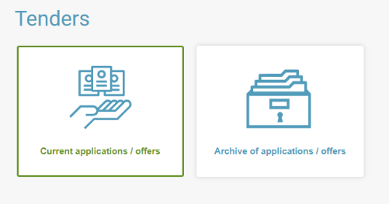
- Current applications/offers: applications/offers submitted for public procurement procedures that are still ongoing, or where the opening of tenders took place less than two years ago.
- Archive of applications/offers: applications/offers submitted for public procurement procedures that have been CLOSED* by the contracting authority, or where the opening of tenders took place more than two years ago.

Within the Archive of applications/offers, users can distinguish between applications/offers submitted up to 1st March 2023 and those submitted on or after 1st March 2023.
* Notice for tenderers: As soon as the contracting authority closes a public procurement procedure (procurement status: "Closed"), the tender is automatically moved from “Current Applications/Offers” to the “Archive of applications/offers”.

OPENING OF TENDERS

Where can I see who has submitted the tender for the public procurement?
If you have not submitted the tender, you can review the submitted tenders (for procedures enabling a public review of tenders) under the "Current public procurements" after the expiry of the deadline for the opening of tenders.
- Find the public procurement on the list of "Current public procurements".
- Click on the public procurement to see (detailed) basic data of the public procurement.
- Click on the "Review of tenders" on the right hand side.
- A list of tenderers with values of their individual tenders will open.
- By clicking on an individual tenderer, their total tender value and pro-forma invoice will be displayed. By clicking on theicon, the pro-forma invoice will open.
If there is no "Review of tenders" on the right hand side, then the deadline for the opening of tenders has not expired yet or the time for a public review of tenders has expired.
A video presentation, where is seen who has submitted the tender.
If you have submitted the tender, you can review the minutes on the opening of tenders and pro-forma invoices after the deadline for the opening of tenders until the completion of the public procurement procedure.
- Find the tender from the list of your tenders and click on it.
- The basic data of the tender will be displayed.
- Following the opening of tenders, the "Competitive tenders" button is displayed on the right hand side, as part of the data on the public procurement.
- Click on the "Competitive tenders" button.
- The same overview of tenderers as with the public opening of tenders will be displayed.
- You can print out the minutes on the opening of tenders by clicking the "Print the minutes on the opening of tenders" button.

If there is no "Competitive tenders" button on the right hand side, then the deadline for the opening of tenders has not expired or the public procurement procedure has not been completed yet.

BRIEF DESCRIPTION OF FUNCTIONALITIES OF THE e-JN SYSTEM
The e-JN system includes the following functionalities:
- My e-JN desktop with an array of functionalities which you may use depending on your rights,
- Invitations to participate in public procurements,
- Tenders:
  - Entry of a request to participate/tender,
  - Submission of a request to participate/tender,
  - New version of a request to participate/tender,
  - Withdrawal of a request to participate/tender,
  - Re-submission of a request to participate/tender,
  - Submission of a clarification when asked to supplement the request to participate/tender,
  - Participation in negotiations,
  - Participation in e-Auctions.
- Notification centre and information.

My e-JN
Following a successful login, your name and surname and the name of the entity for which you will be submitting tenders will be displayed in the upper right hand section. Next to your name, you can also find icons to access help, discover what is new (in the e-JN system), access to the Notification centre and the option to change language.
After clicking on the user profile , the following options to manage the profile are displayed:
- "My user accounts" – enables an overview of all user accounts and determining the default user account.
- “Login with a different account” – enables the switch between user accounts or logging in with a different user account (if you are submitting tenders for several tenderers).
- “Edit contact details” – enables the changing of the e-mail address.
- “Logout” – logging out from the application.
The following icons are available on the desktop (depending on your rights):
- "Current public procurements" with an overview of published public procurements.
- “Notifications” with an overview of notices from Notification centre.
- " Public contracts with invitation" with an overview of invitations by contracting authorities to participate in public procurements, which are not made public on the public procurement portal.
- "Tenders" with a review of tenders.
- “Users” to manage the rights of system users (if you have corresponding rights).
- "Statistics" – the module is still being prepared.
Access individual pages by clicking icons in the middle of the page or use the menu on the left.
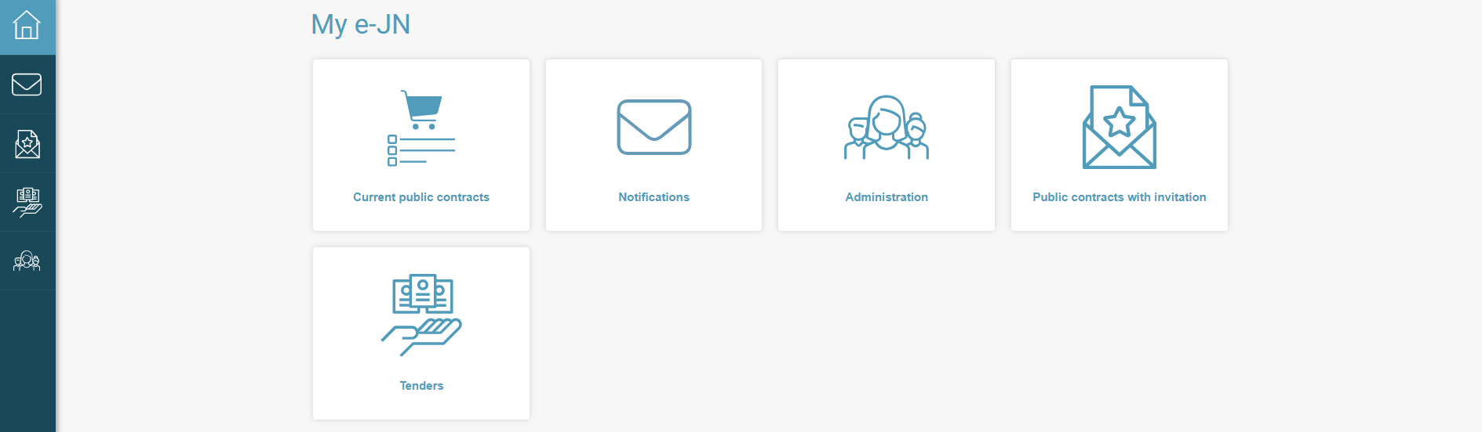
- Work desktop
If clicking on the  system logo in the upper left hand corner, the "e-JN electronic public procurement portal" entry page will open.

Public contracts with invitation

List of invitations
In procedures with an invitation to submit tenders, the invited candidates will see invitations in the "Public contracts with invitation" section. They will also be notified by e-mail at the e-mail address they provided as the contact e-mail upon the registration in their user profile and/or via SMS messages and/or via the notification centre (depending on the notification method settings).
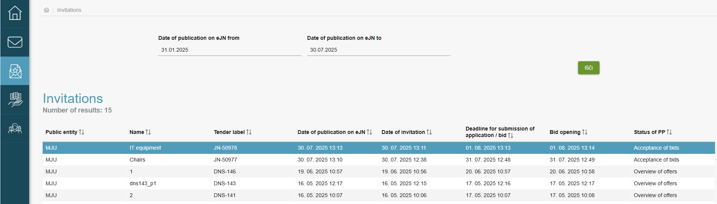
- List of invitations
The basic data on the public procurement and appertaining documentation will be displayed when clicking on the invitation. The "Participate in public contract" button is on the right hand side with which you start drafting the tender for the selected procurement.
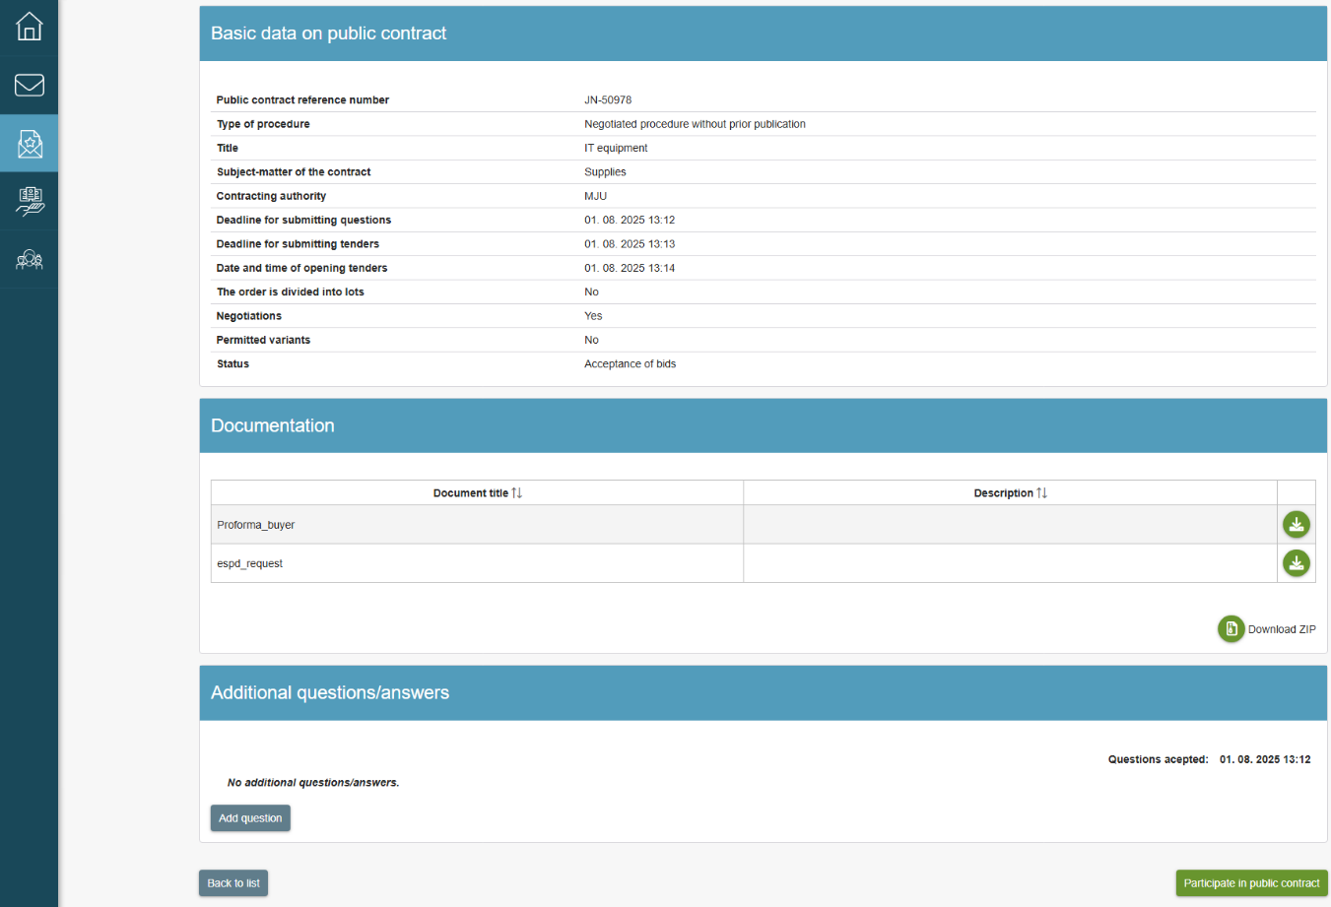
- Detailed overview of the public procurement

Tender

List of tenders
The list of your tenders is shown after clicking the "Tenders" icon. By clicking on the entry, the details of the tender are displayed. A person who can prepare the tender, but cannot submit it, only sees the tenders they have prepared. The person who has the right to submit the tender can see all tenders.
The entries in the table are shown in different colours:
- White entry: the tender was submitted or more than two days are left until the submission.
- Yellow entry: less than two days are left until the submission of the tender.
- Red entry: the deadline for the submission of the tender has expired.
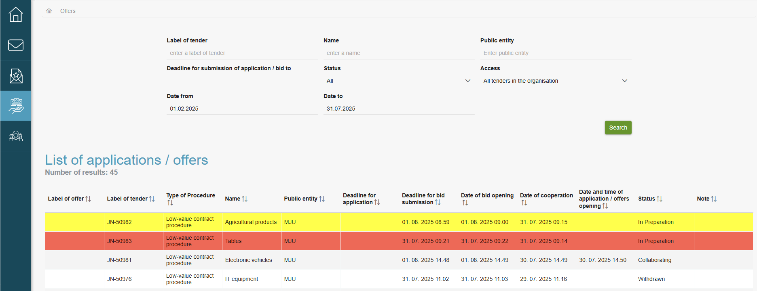
- List of applications / offers

Preparation and submission of a tender
The page is divided into the following sections: basic data on the tender, total tender value and pro-forma invoice, documents and participants.
An e-mail for notification is also displayed. If you wish to change it, enter a new e-mail address and confirm the change in the next field. If the e-mail addresses do not match, the submission is not possible.
When preparing the tender, enter the tender’s internal designation mark and the total tender value, and then attach the completed pro-forma invoice and other documents. If subcontractors are participating in the tender, the tender is joint or the capacities of other entities will be used, all participating entities must be provided and the documents required for them must be submitted.
The tender is divided into the following sections:
- basic data on the tender,
- Bid value with the "Pro-forma invoice" section,
- documents with the "ESPD – tenderer" or the "Statement – tenderer" sections and the "Other attachments" section,
- participants with the "ESPD – other participants" or the "Statement – other participants" sections.
The permitted file format in the "Pro-forma invoice" section include PDF, Word or Excel. Only one file may be attached, except in the event of variant tenders where a document must be attached separately for each variant. The document attached in the "Pro-forma invoice" section is fully visible at the public opening of tenders together with the total tender value. If the reverse electronic auction takes place at the public procurement, the system will automatically draft the pro-forma invoice. See Point 6.4.
The ESPD form in XML format is mandatory, except for procedures that allow the tenderer to attach their own statement. If other entities participate in the tender, they must also sign the ESPD form and submit it (in XML or PDF format).
The remaining documentation is attached to the "Other attachments" section. By clicking on the "Upload supporting documents" button, the " Supporting documents " window opens, where you can select the evidence you need deposited by the tender's main administrator in the Administration section. If a certain piece of evidence is not among the listed evidence, contact your administrator (see also point 6.4. Uploading evidence).
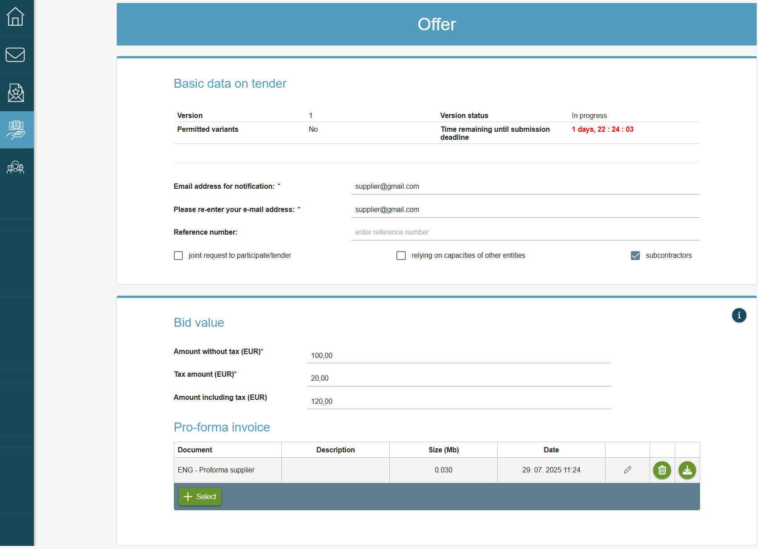
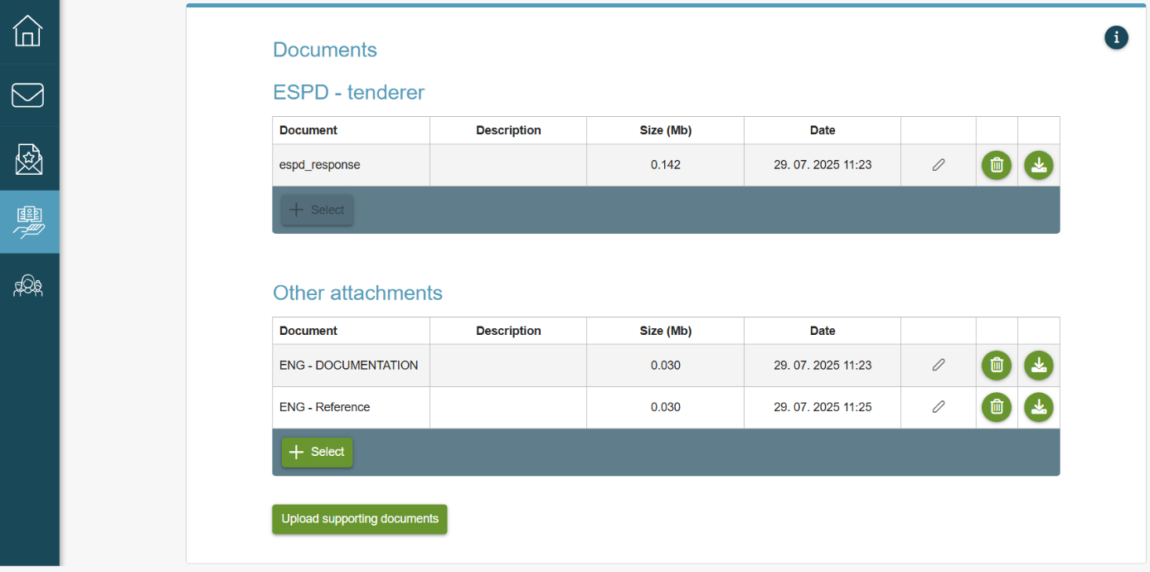
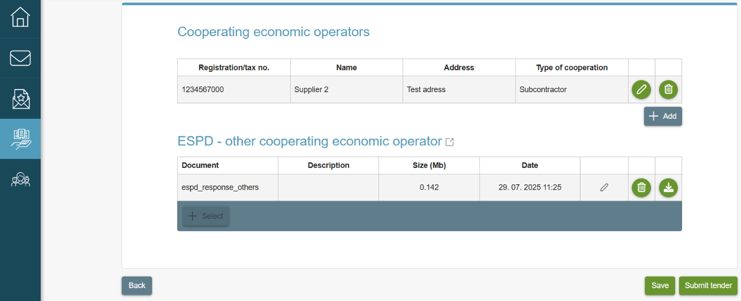
- Entry of the tender

The following buttons are found at the bottom of the page:
- "Back" – to return to the first page of the tender,
- "Save" – to save data,
- "Submit the tender" – to submit the tender.

To use the "Submit the tender" button, it is necessary to hold suitable rights. Otherwise, this must be done by someone who has such rights.

After clicking the "Submit" button, a window opens in which the economic operator submitting the tender accepts the general terms and conditions and submits the tender by clicking on the "Submit" button.
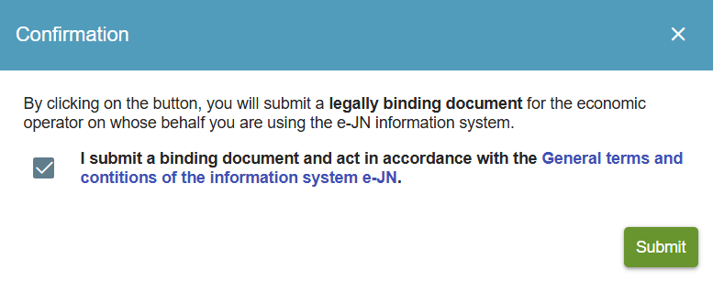
- Submission of the tender
After confirmation, the tender is submitted to a safe registry until the deadline for opening the tenders.

WARNING!
The e-JN system does not allow the submission of several tenders simultaneously for the same public procurement if, for example, an entity would like to submit the tender as an independent tenderer and also as a leading partner in a joint tender.

Review of the basic data of the tender
Following the entry of data of the tender and the submission, the basic data about the procurement and the tender are displayed on the first page of the tender:
- basic data on the public procurement on the "More information" button,
- data on the submission of the tender,
- data on the versions of the tender.

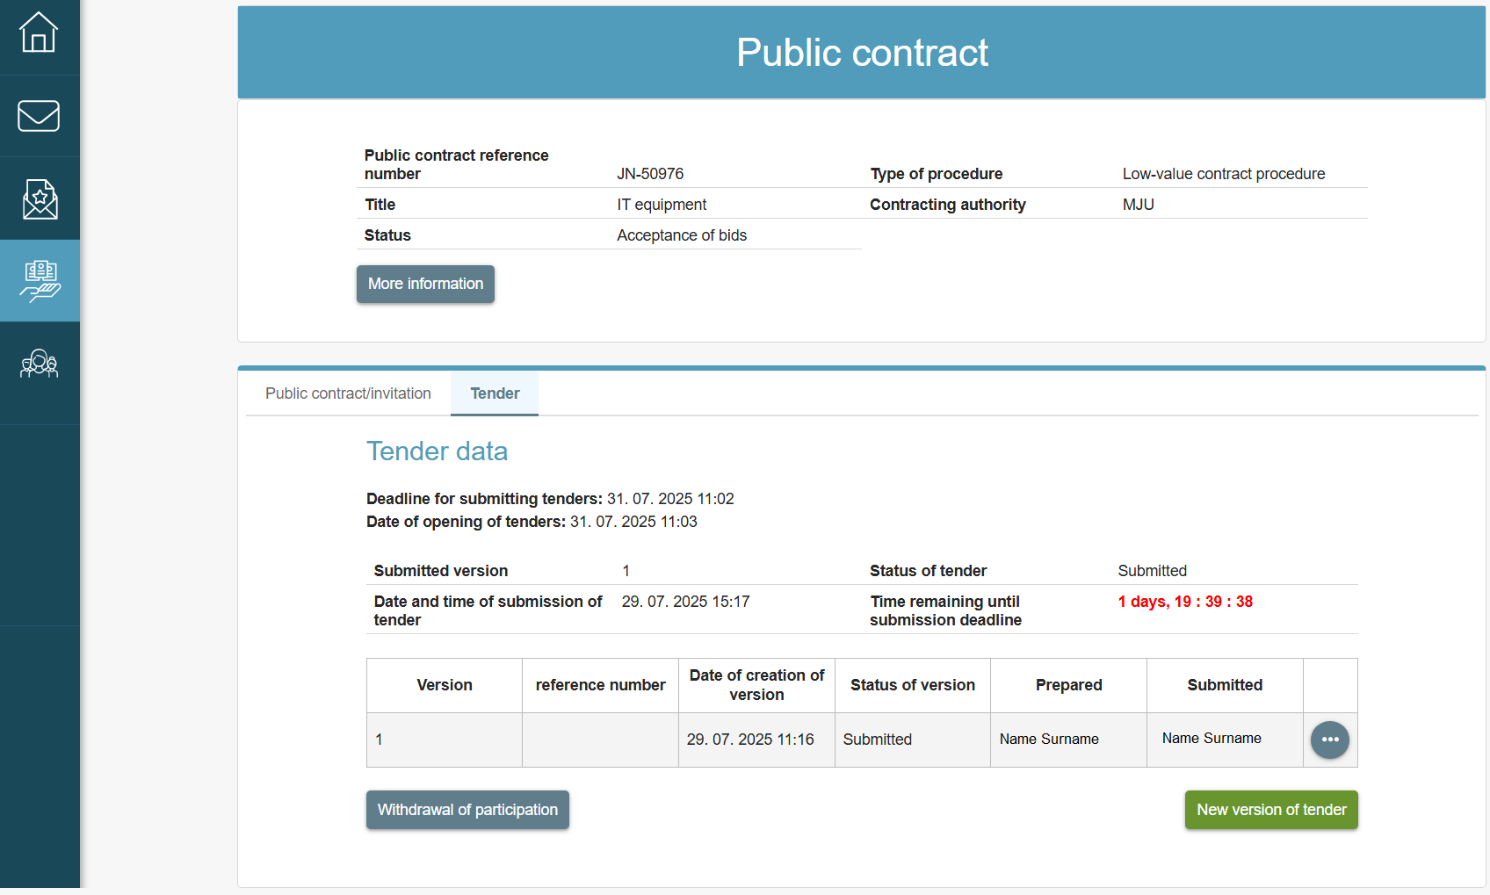
- First page of the tender with basic information
If the deadline for the submission and opening of tenders has not yet expired, the following buttons are found on the page:
- "More information" – for a detailed review of the public procurement and documentation which the contracting authority failed to publish on the public procurement portal.
- "New version of the request to participate/tender" – preparation of a new version if one had already been submitted. The button is active until the submission deadline.
- "Delete the version" – to delete a new version that was not submitted. A withdrawal of the version that was not submitted (is being drafted) is also possible after the expiry of the submission deadline.
- "Withdrawal of participation" – to withdraw the request to participate/tender. The button is active until the submission deadline.
- "Prepare again" – to draft the withdrawn request to participate/tender again and submit it. The button is active until the submission deadline.
If the deadline for the submission and opening of tenders has already expired, the following buttons are found on the page:
- "More information" – for a detailed review of the public procurement and documentation which the contracting authority failed to publish on the public procurement portal.
- "Competitive tenders" – review of competitive tenders after the opening of tenders and a printout of the minutes on the opening of tenders. The button is active until the completion of the procedure in the e-JN system.
By clicking on the submitted tender, it is possible to review the tender and print the certificate that the tender was submitted by clicking the "Print the submission certificate".
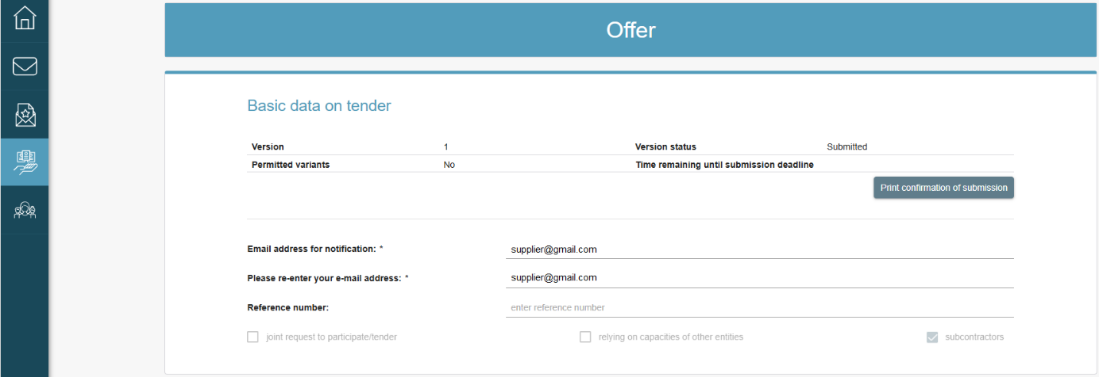
- Printing the certificate on the submission of the tender

Changing the tender
If you have already submitted the tender, you may submit a new version until the deadline for the submission of tenders. On the first page for the review of tenders, click on the "New version of the tender" button. The data of the submitted tender will be transferred to the new version where the data can be changed and deleted and/or new documents can be added. The previously submitted tender will be cancelled.
If the contracting authority has made a change of the public procurement (e.g. change of the deadline of tender submission, change of the deadline for opening tenders, change of the pro-forma invoice), you can also submit a new tender.

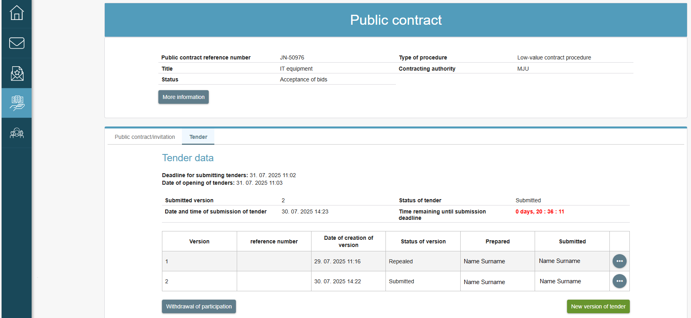
- Changing the tender
In the case when a change of the public procurement with change of pro-forma invoice has been made and the deadline of tender submission has not yet expired, a notification is displayed on the screen: “There has been a change in this public procurement after you have already submitted the offer. In order to avoid errors or incorrect display of tenders, please submit a new version of the offer, because your offer was not submitted on the modified pro-forma invoice.” This can be done by the deadline of tender submission.”

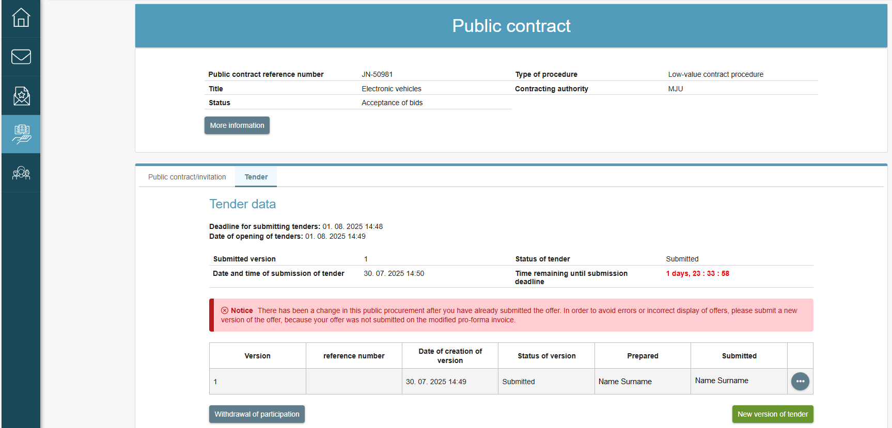
- Change of public procurement with change of pro-forma invoice

Withdrawal of the tender
You can withdraw the tender until the deadline for the submission of tenders. On the first page for the review of the tender, click on the "Withdrawal of participation" button. The tender will be withdrawn.

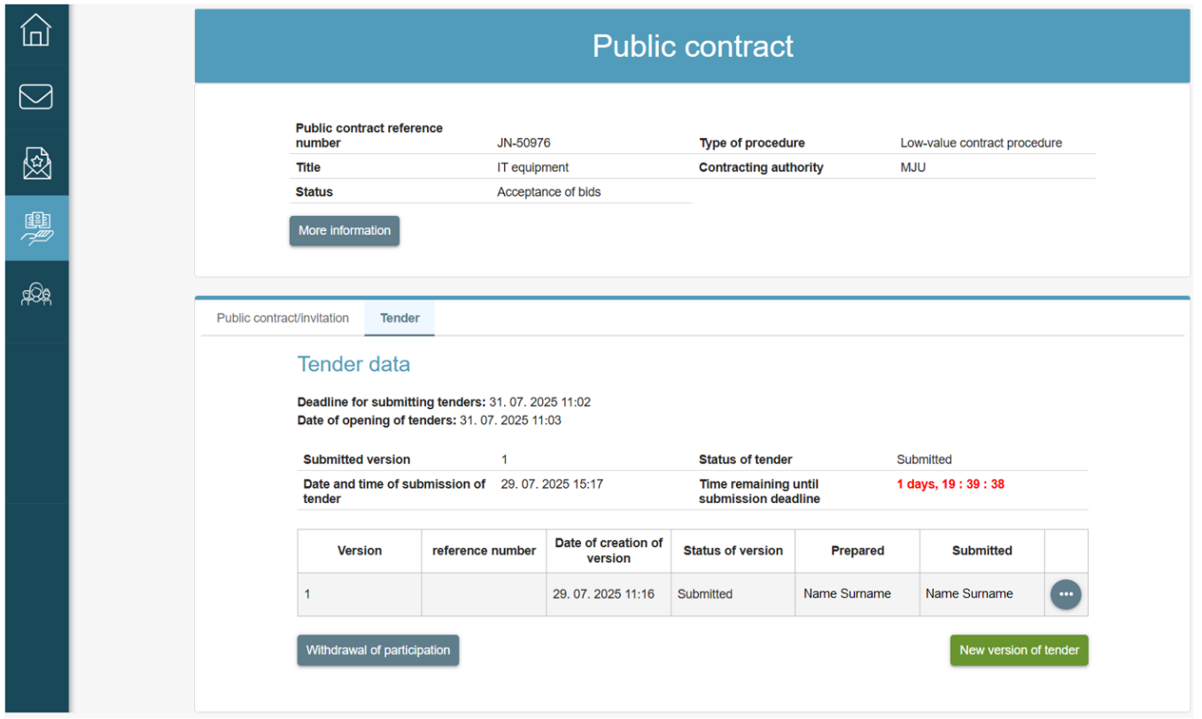
- Withdrawal of the tender

Re-submission of the tender
Although the tender was withdrawn, it is possible to submit it again until the submission deadline. Click on the "Cancel withdrawal of participation" button on the first page for the review of the tender where the latest version of the tender will upload. Prepare or supplement a new version of the tender, which can then be submitted.
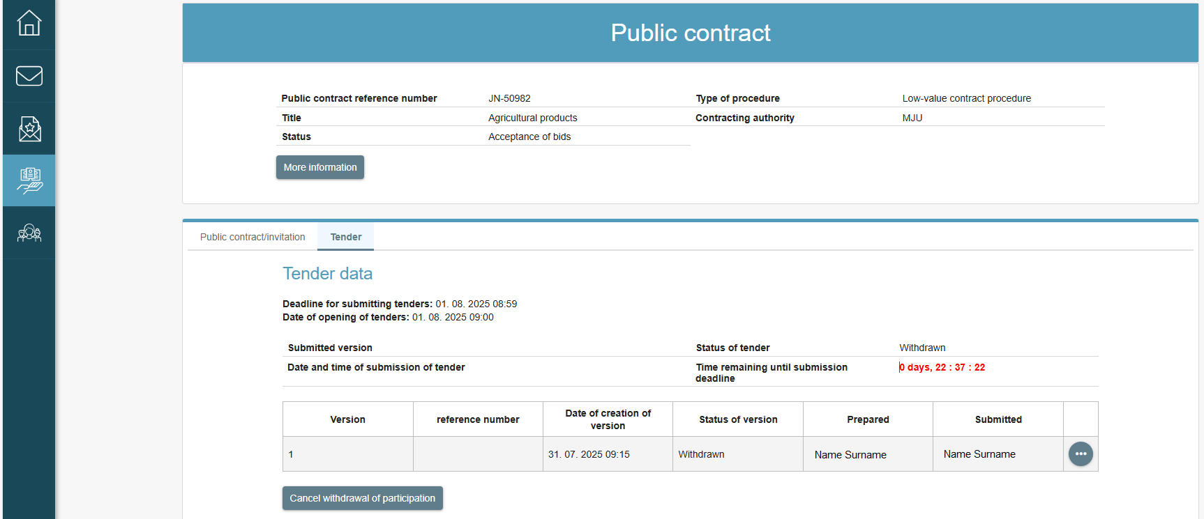
- Re-submission of the tender

Review of the minutes on the opening of tenders
The competitive tenders will be visible in your system after the deadline for the opening of tenders. On the first page for the review of your tender, click on the "Competitive tenders" button. Information on the names of the tenderers who submitted their tenders will be displayed, including the data on whether theirs were variant tenders (if appropriate) and the total tender value of each individual tender. By clicking on an individual tenderer, it is possible to examine their pro-forma invoice. The data will be shown until the completion of the public procurement. Other data and documentation regarding competitive tenders are not visible. By clicking on the "Print the record of the openings" button, the tenderer can see the basic data on the public procurement, the list of tenderers, the data on variant tenders (if appropriate), the time of submission of individual tenders and the total tender value of each individual tender. The minutes on the opening can be printed out or saved.
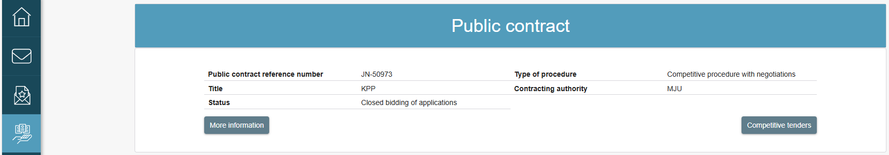
- Review of the minutes on the opening of tenders

If the contracting authority has stated in the public procurement (in accordance with the provisions of the PPA-3) that negotiations would be implemented, the visibility of competitive tenders is explained in more detail in the Answers to frequently asked questions, under point 10.

Submission of the tender with or without lots
- Public procurement without lots
If the contracting authority did not divide the public procurement into lots within the e-JN system, enter the ”Amount without tax (EUR)” and “Tax amount (EUR)”in the "Bid value" section. The “Amount including tax (EUR)” is calculated automatically. Upload the Word, Excel or PDF file in the "Pro-forma invoice" section.
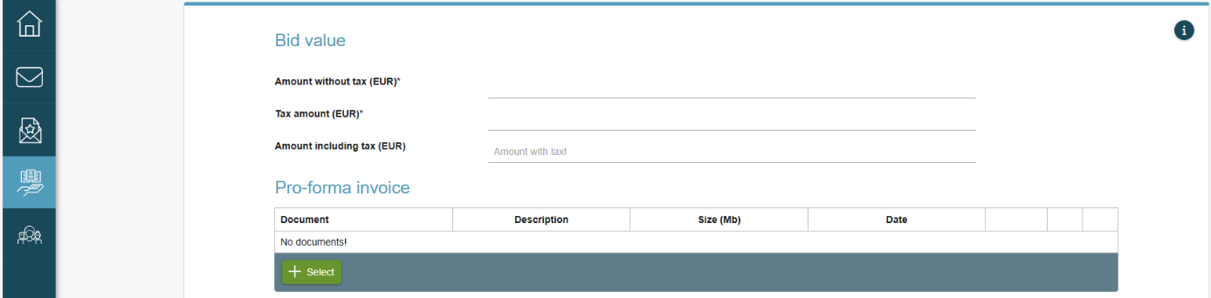
- Submission of the tender without lots

- Public procurement with lots
If the contracting authority divided the public procurement into lots within the e-JN system, enter the ” Amount without tax (EUR)” and “Tax amount (EUR)”for an individual lot in the table in the "Bid value" section. The “Amount including tax (EUR)” is calculated automatically. Upload the Word, Excel or PDF file in the "Pro-forma invoice" section.
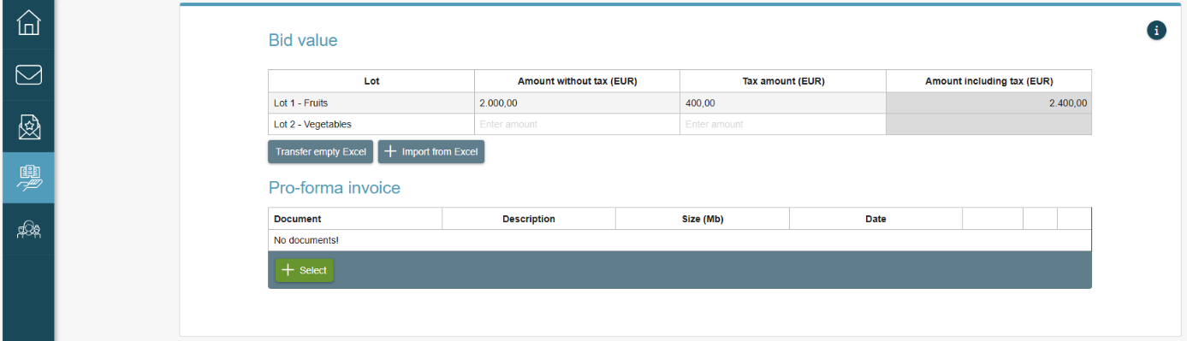
- Submission of the tender with lots

Submission of the tender with variants (variant tenders)
If the public procurement enables the submission of a tender with variants, several variants may be submitted for one public procurement. The first variant is entered by entering amounts for “Amount without tax (EUR)” and “Tax amount (EUR)” in “Bid value” section. The “Amount including tax (EUR)” is calculated automatically. Click on the "Select" button and add the pro-forma invoice. To add another and all subsequent variants, click on the "+" button next to Option1. Enter prices (amounts) into the fields and add the pro-forma invoice in the same way as in the first variant.
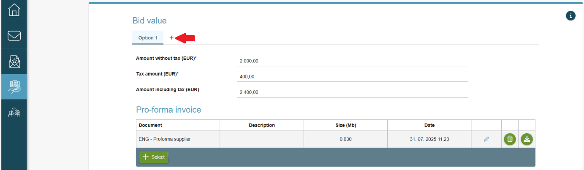
- Variant tenders

Submission of a tender in the case of auction
If the contracting authority noted that an auction would be included in the public procurement, the pro-forma invoice was prepared within the e-JN system. In the "Bid value" section, first click on the "Prepare the pro-forma invoice for e-auction" button.
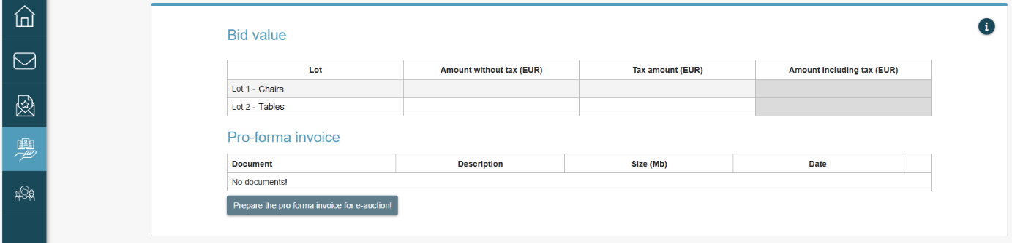
- Pro-forma invoice in the case of an e-auction
The figure below is shown. The pro-forma invoice can be completed in two ways.

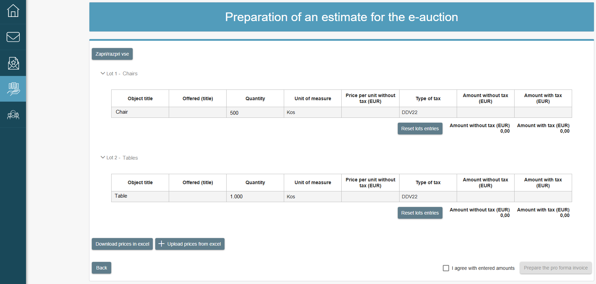
- Preparation of a pro-forma invoice for an auction

- Direct entry of data in tables
By clicking on the "Offered (title)" cell in the table earmarked for each individual lot, enter what you offer and then move to "Price per unit without tax (EUR)" cell and complete it. Check or select the correct type of tax in the "Type of tax" cell in the drop-down list. "Amount without tax (EUR)" and "Amount with tax (EUR)" are calculated automatically in the table.
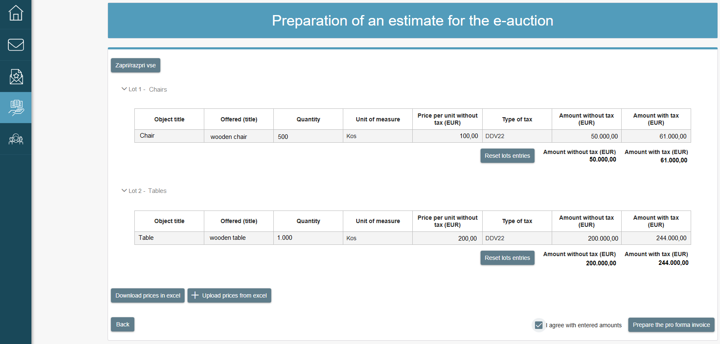
- Completing the pro-forma invoice for an auction
By confirming that you agree with the prices entered and by clicking on the "Prepare the pro-forma invoice" button, the data is automatically transferred to the "Bid value" section and the pro-forma invoice is automatically uploaded in the "Pro-forma invoice" section.

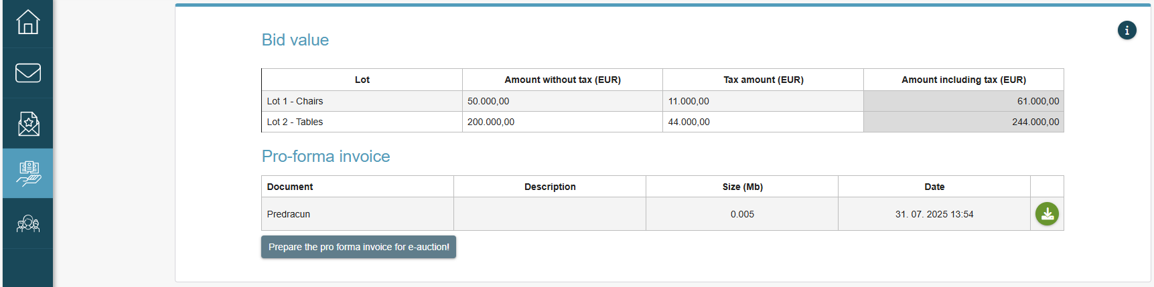
- Completed "Total tender value" section for the auction

- Entry of data through the Excel file
If you wish to draft the pro-forma invoice and then import it from the Excel file, you have to download the Excel file by clicking on the "Download prices in Excel" button. Save and complete the file on your computer. By clicking on the "+ Upload Excel with prices" button, the completed table on your computer will be uploaded back in the application where all data in tables will be displayed by lots. Similarly as in Figure 17 when the pro-forma invoice is submitted with a direct entry in the tables.
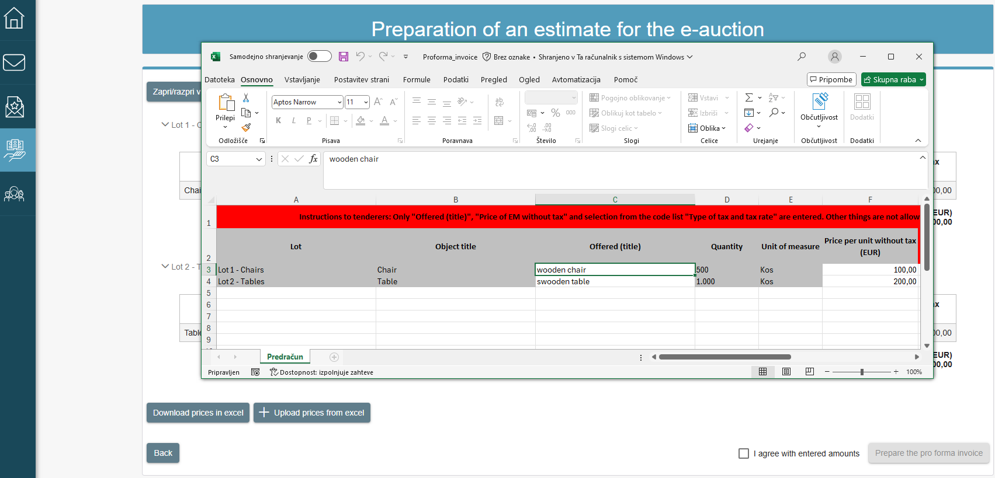
- Completing the pro-forma invoice for an auction through an Excel file
By confirming that you agree with the prices entered and by clicking on the "Prepare the pro-forma invoice" button, the data is automatically transferred to the "Bid value" section and the pro-forma invoice is automatically uploaded in the "Pro-forma invoice" section. Similarly as in Figure 18 when the pro-forma invoice is submitted with a direct entry in the tables.

Invitation to negotiations
If it was stated in the public procurement that negotiations would be implemented, the contracting authority will invite you to every round of negotiations via the e-JN system. You will receive an invitation to negotiations by e-mail and/or via SMS messages and/or via the notification centre (depending on your notification method settings).
The data on negotiations can be found on the first page of your tender. If a new tender must be submitted for negotiations or in the case of the last round of negotiations, the new version of the tender is submitted in the same way as described in point 6.3.2. (Preparation and submission of a tender).
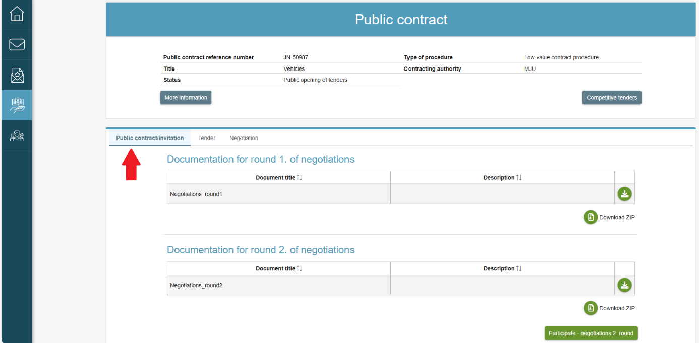
- Invitation to negotiations

Invitation to supplement the request to participate/tender
If the contracting authority sent you an invitation to supplement/clarify, you will receive the invitation by e-mail and/or via SMS messages and/or via the notification centre (depending on your notification method settings). The invitation will be visible in the review of the tender under the submitted request to participate/tender.
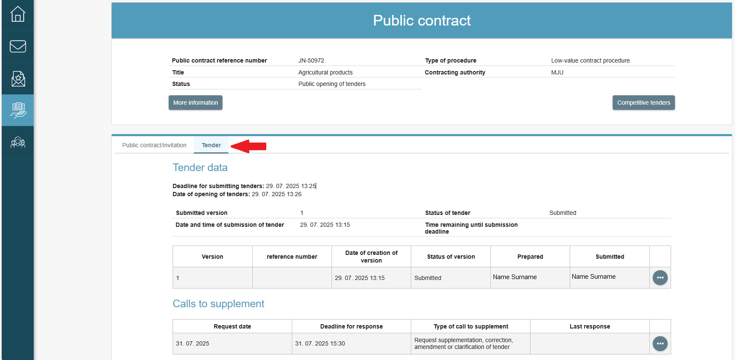
- Invitation to supplement the request to participate/tender
The supplementation must be submitted by the supplementation deadline. A later response to the invitation is not possible. When clicking on  in the review of invitations to supplement, a new window with the invitation details will open:
- The contracting authority’s documentation is in the upper section.
- The possibility of adding supplements or reviewing the submitted supplements is found in the lower section.
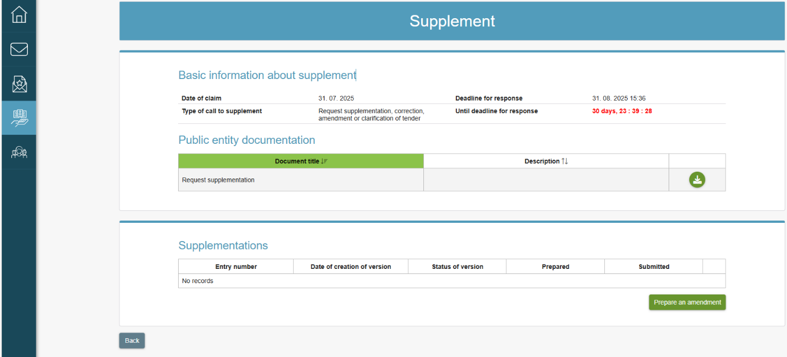
- Supplementing the tender
When entering the supplement (by clicking on the "Prepare an amendment" button), it is mandatory to attach the PDF file in the "Documents" segment of the "Answer" section. Files of different formats (Word, Excel, PDF, TIF, JPG, etc.) may be attached in the "Other attachments" section. When clicking on the "Submit supplement" button, a window will open in which the entity submitting the supplement agrees to the General Terms and Conditions and confirms that they are submitting a legally binding document, which they submit by clicking on the "Submit supplement" button.
Several supplements may be submitted until the deadline for the submission of supplements.
The contracting authority sees the reply or supplement immediately after successful submission. The contracting authority also receives a notification about the submission of the reply or supplement by e-mail and/or via SMS messages and/or via the notification centre (depending on your notification method settings). It is thus not possible to cancel the submission.

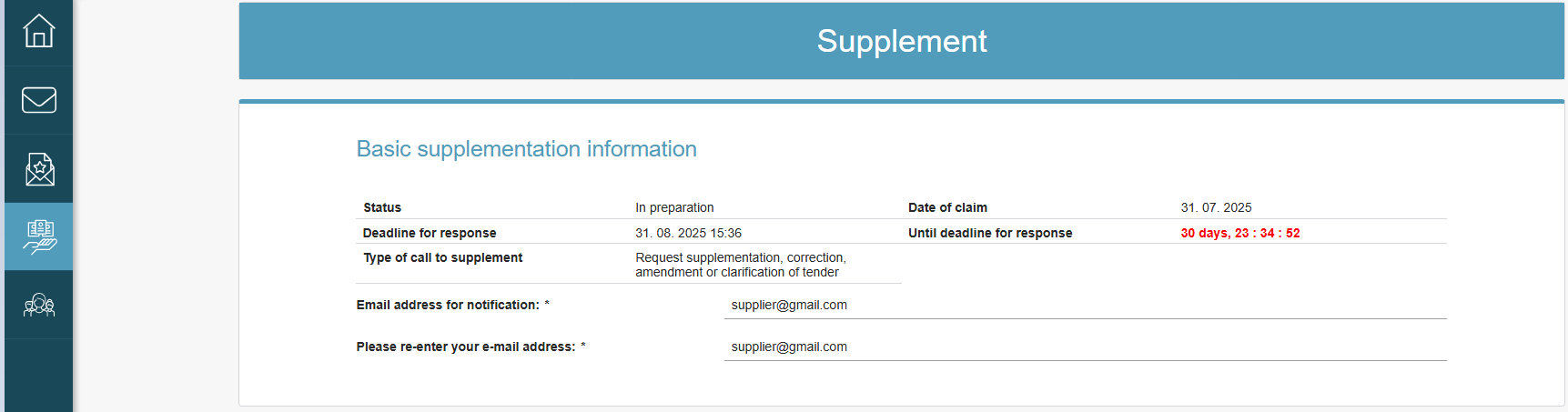
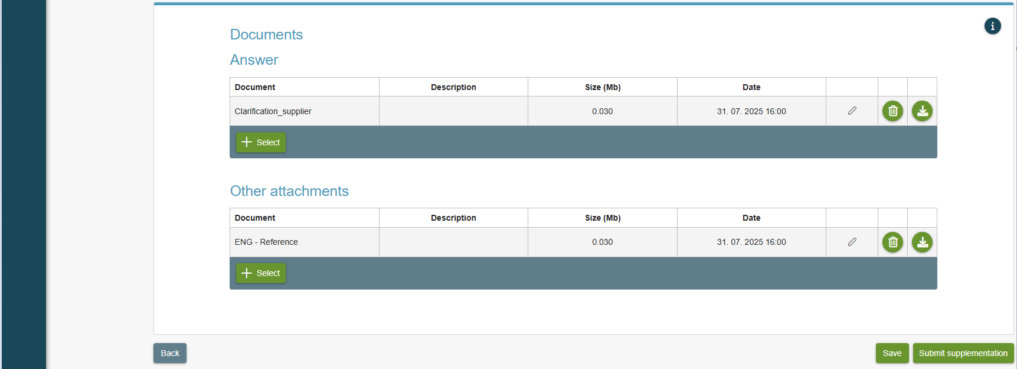
- Tenderer’s reply

Uploading supporting documents
The administrator of tenderer can enter the supporting documents for submitting tenders that are deposited in the e-JN system. Administrator selects the business entity via the "Administration" icon, then the "Business entities" icon, and then again via the "Business entities" icon.

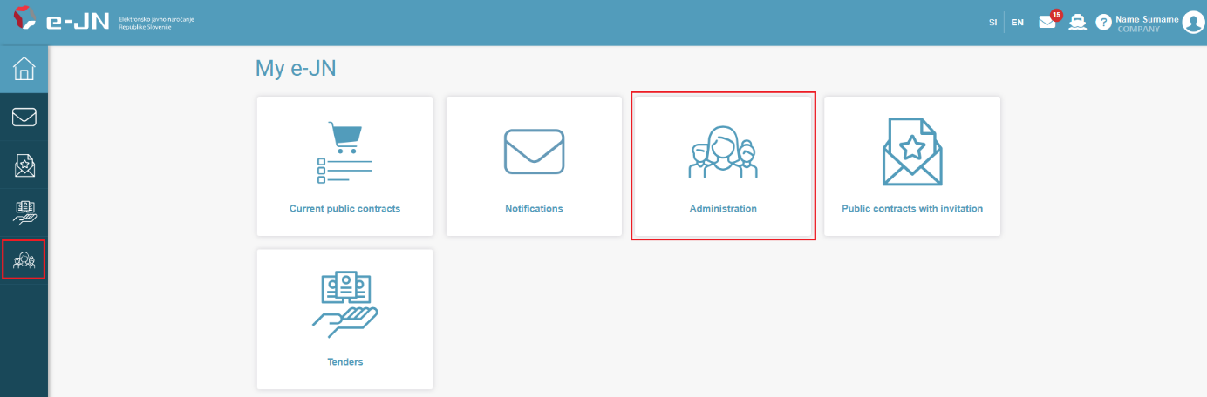
- Work desktop
The page with the information on business entity opens. "Number of supporting documents" shows the current number of supporting documents uploaded in the e-JN system.

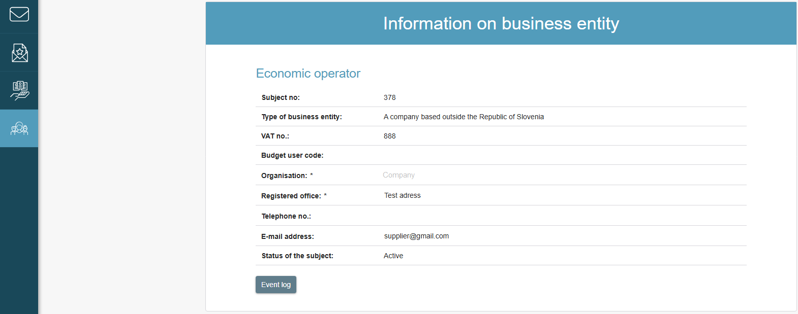
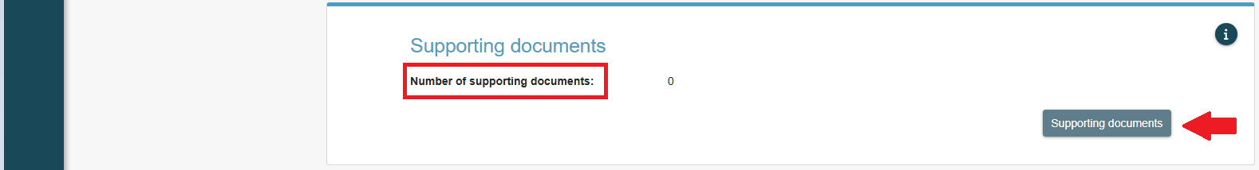
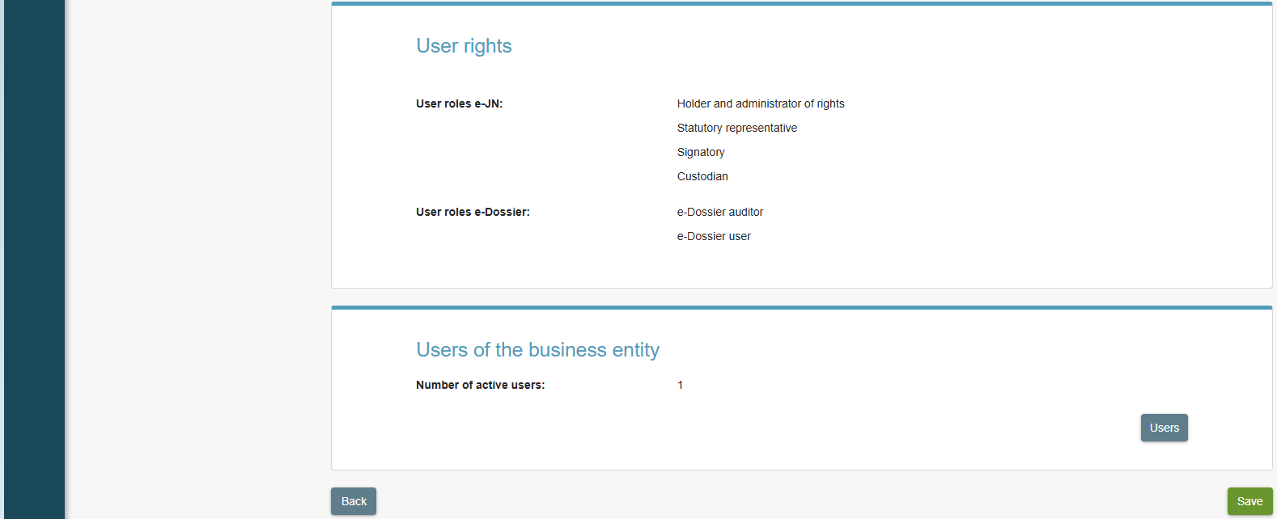

- Information on business entity
By clicking on the "Supporting documents" button, the "Supporting documents of a business entity" window will open. The types of supporting documents that the tender can upload are: CVs, certificates, references, human resources data, company ownership statements, etc. The tenderer can upload documents that are not named among the types of supporting documents under "Other" (e.g. licenses for road transport). By clicking on the "+ Select" button for each type of supporting documents, upload the evidence that you want to have in the e-JN system for the purposes of submitting tenders.

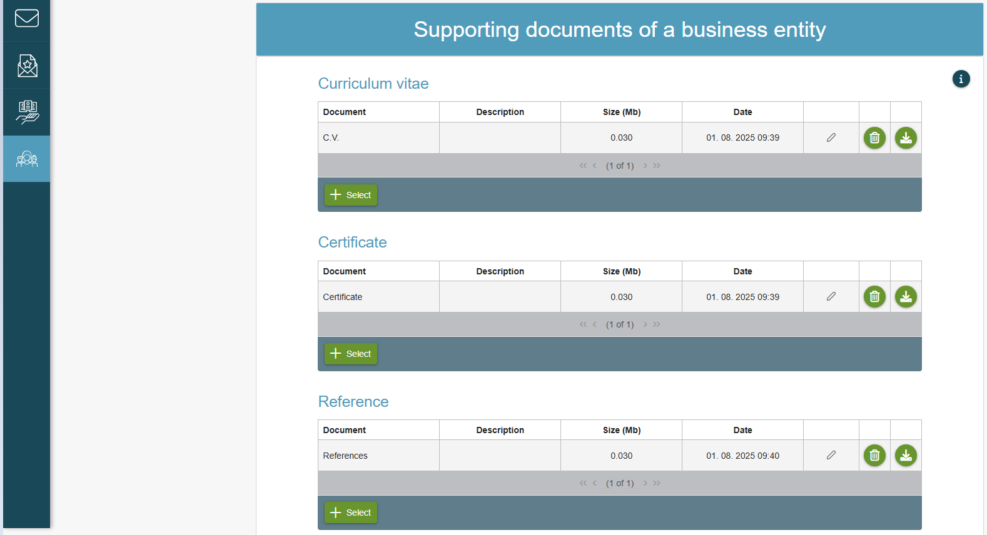
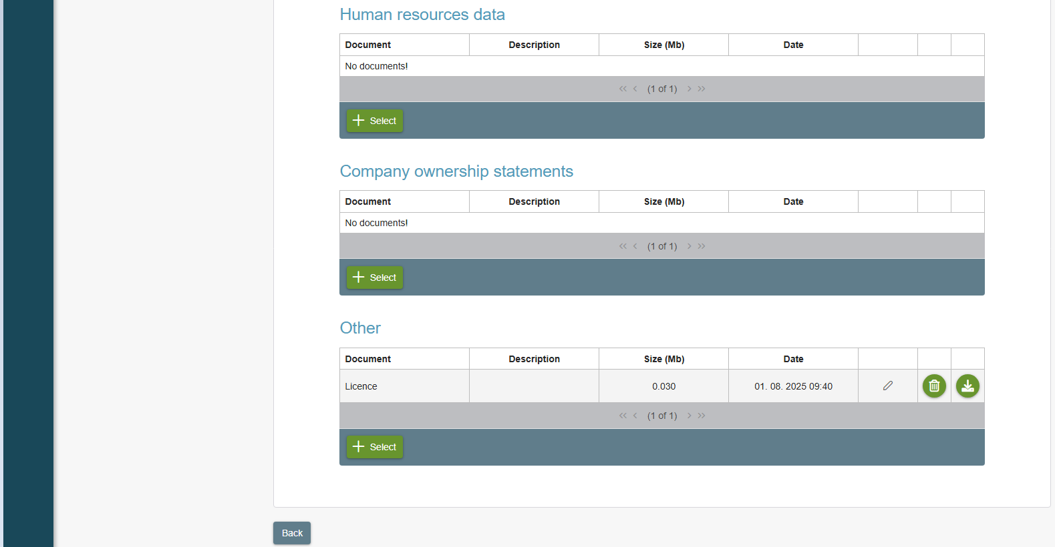
- Supporting documents of a business entity
When the administrator of tenderer uploads for the first time an individual supporting document to the " Supporting documents of a business entity " section, this supporting document is deposited in the e-JN system and is available to the tenderer every time he submits an application or a tender. On the main page for submitting a tender (application), the provider has a button "Upload supporting documents" in the "Offer" section.
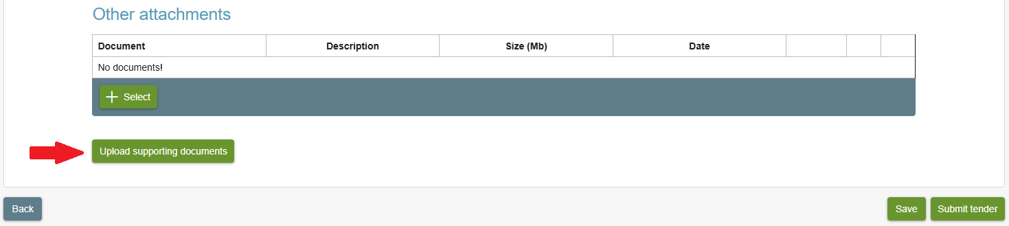
- Enter the tender

By clicking on the button, the "Supporting documents" window opens, where the tenderer selects the evidence he needs.

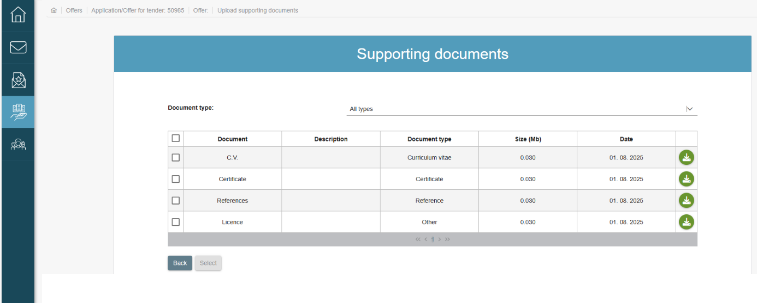
- Supporting documents

E-AUCTIONS

Functionality of the e-Auctions
1. Regular auction

Takes place at the time and duration as determined by the contracting authority. At the beginning of the auction, the tenderer’s user may lower the price relating to their previous tender. In the procedure of regular auction, the tenderer may only lower the prices of individual items, but cannot increase them irrespective of the total value of the procurement/lot. During the auction, the e-JN system does not permit the submission of the same prices per procurement/lot as have already been submitted and automatically generates a message displayed on the user’s screen while also disabling the submission of new prices.

A video presentation of the implementation of the reverse electronic auction.

AUCTION EXTENSION:

If the contracting authority anticipated the extension of the auction in the e-Auctions, they enter the parameters, i.e. the time before the completion of the auction in which a new tender must be submitted and the time for which the auction is extended. If a new tender was submitted within a certain time frame before the completion of the auction (this tender may not be necessarily most favourable), the auction does not end at the time initially anticipated, but is extended for the time determined by the contracting authority. The extension continues until none of the tenderer’s users submits a new tender in the time frame determined by the contracting authority.

A video presentation of the completion of the reverse electronic auction.

2. Time-interval auction

Time-interval auction takes place in a certain number of intervals with limited duration. The parameters of the auction (no. of intervals and duration of each interval) are determined by the contracting authority and defined in tender documents.
The tenderer’s user may submit several tenders in individual intervals (changes individual prices several times), although each subsequent tender must be lower than the previous one submitted in the interval. Within an interval, the tenderer may also increase the price, but only for the amount submitted in the previous interval.

A video presentation of the implementation of the time-interval reverse electronic auction.

The tenders are revealed at the end of the interval. If the tenderer’s user submitted several tenders within the interval, only the last lowest tender submitted is revealed.
A video presentation of the completion of the time-interval reverse electronic auction.

The data on whether the contracting authority anticipated the e-auction in the procedure of awarding the public procurement is evident from the basic data of the public procurement in the system.

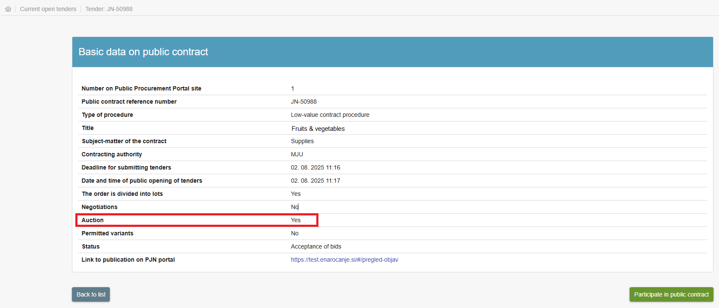
- Basic data of the public procurement
You can participate in the auction after the contracting authority invited you to the auction following the examination of tenders. In which case, you will receive an e-mail with an invitation to the auction to the e-mail address provided in the tender.

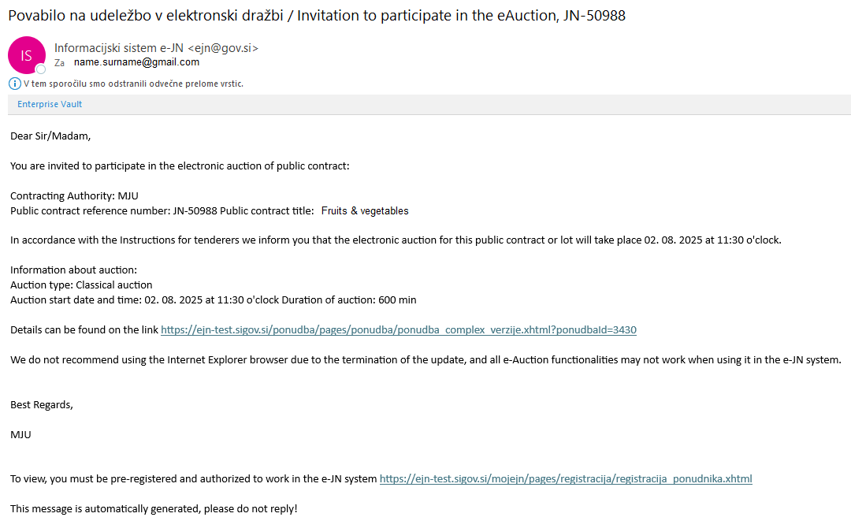
- Invitation to participate in the e-Auction

Just before the auction, the tenderer receives a reminder to the e-mail address provided in the tender.

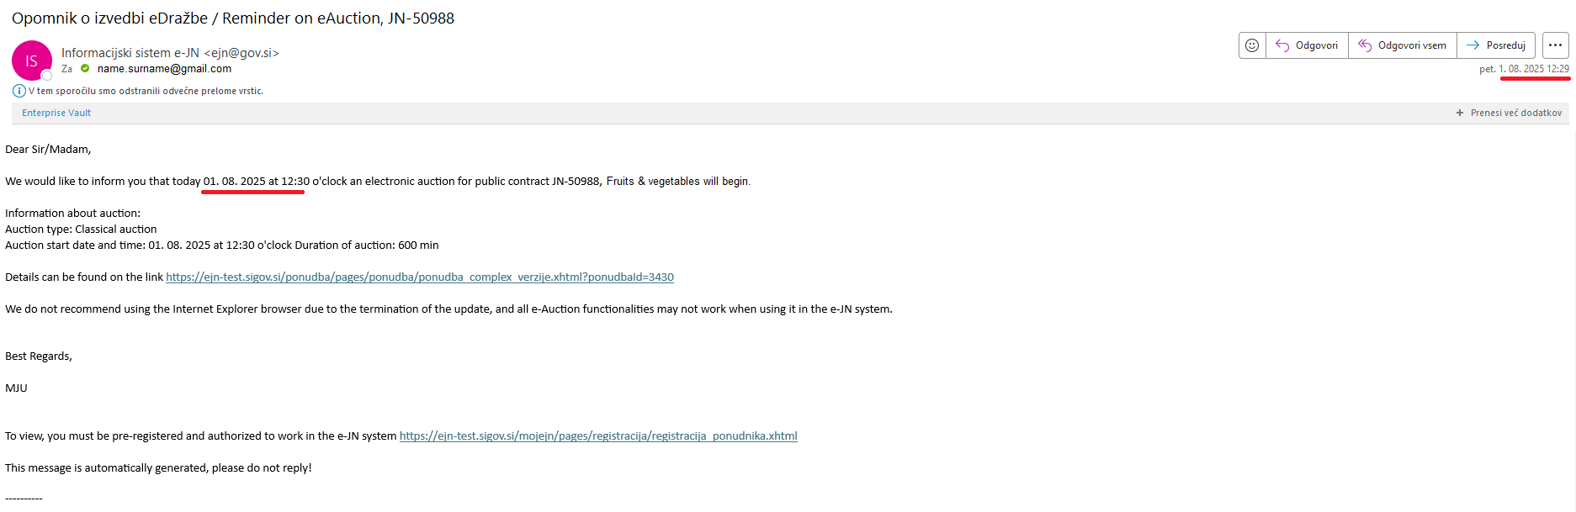
- Reminder on the implementation of the e-Auction

Participation in the e-Auction
If you are invited to partake in the e-Auction, you will see the "Participate – auction 1. round" button in your tender.

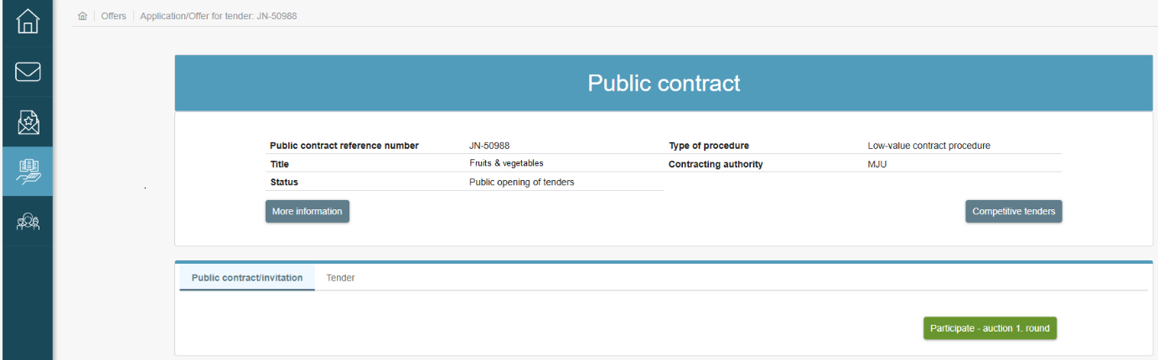
- Enter the e-Auction
The "Submitting new tenders" window opens after you click on the "Participate – auction 1. round" button. When confirming the General Terms and Conditions for the Use of the e-JN System by clicking the "I agree" button, you agree to submit legally binding tenders after entering the auction when participating in the e-Auctions procedure for the economic operator on the behalf of which you are using the e-JN system.
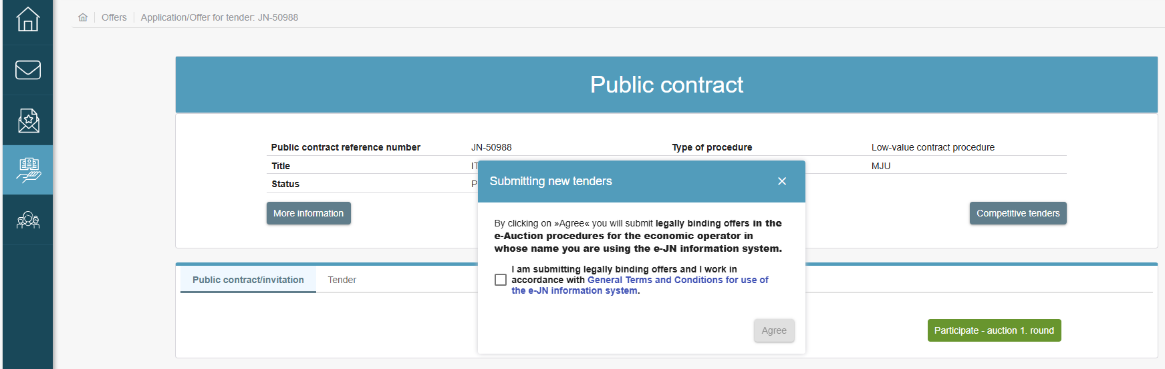
- Confirming the submission of the legally binding tender before entering the e-Auction
Following the confirmation, the e-JN system will open a page where the amounts submitted last during the implementation of the auction will be transferred after the completed auction.
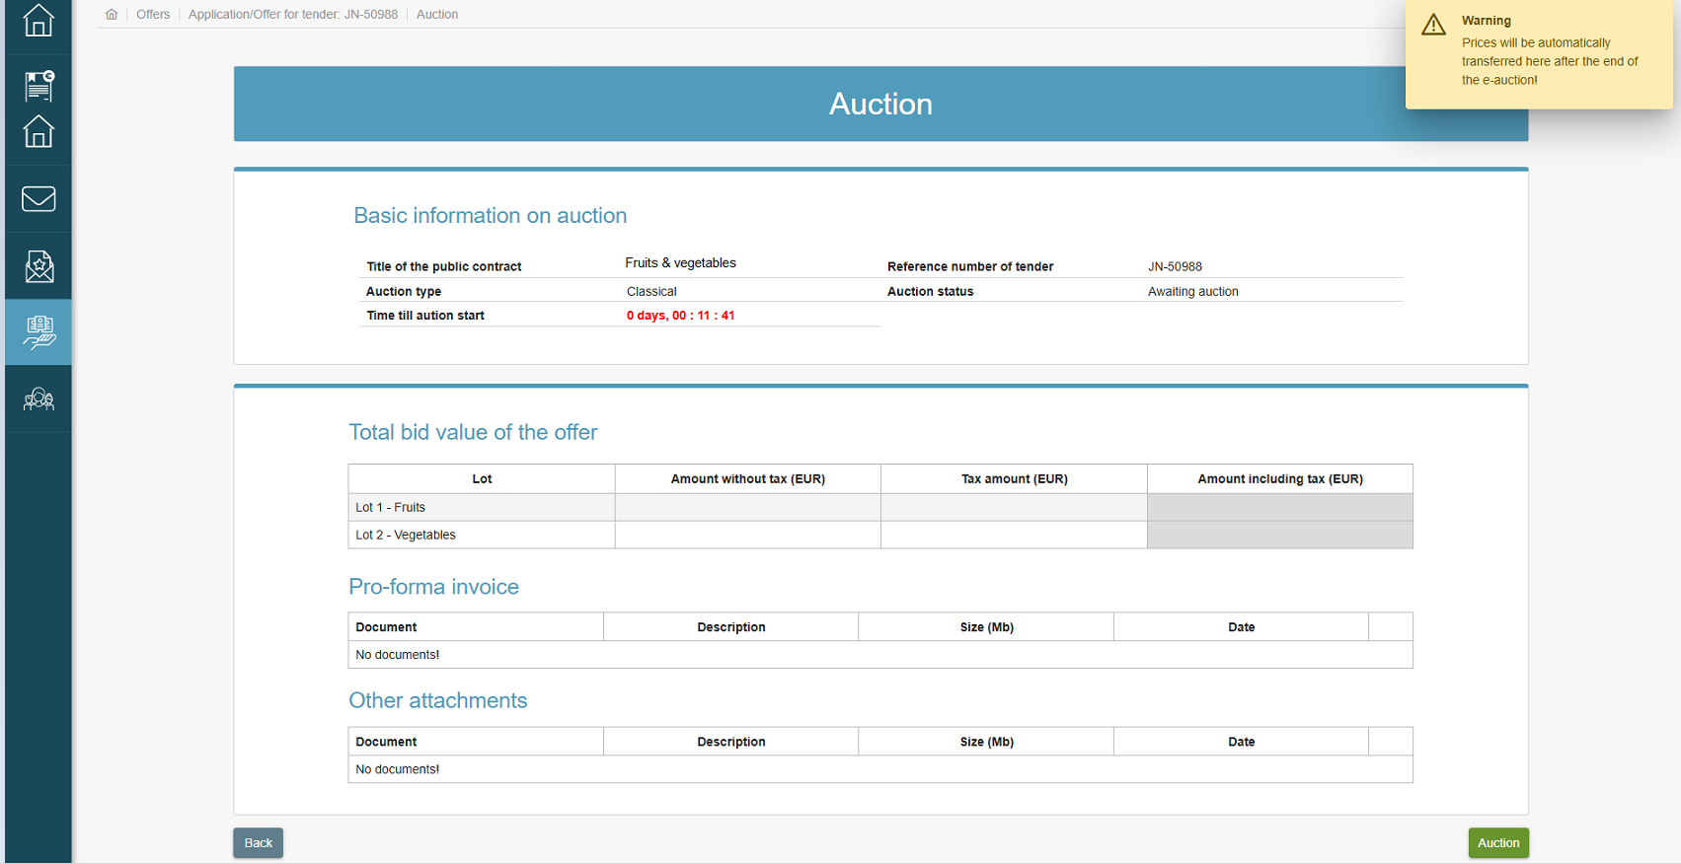
- Auctioned tender
To access the auction, click on the "Auction" button. You will be redirected to the page where your prices submitted in the tender will be displayed.
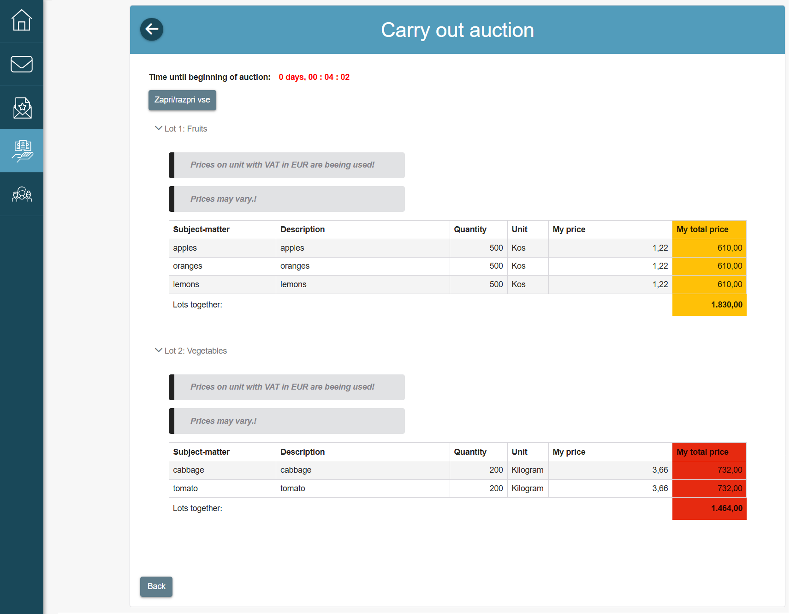
- Table before the start of the auction
Once the auction starts, you will be able to see your tender in the table(s) on the left hand side of the screen (depending for which lot the auction takes place if the procurement is divided into lots) and the tenders of three, currently most favourable tenderers. At any time during the auction, the participating tenderer may check their placement in the table(s) on the right hand side of the screen in the "My placing" section (for an individual lot for which the auction takes place if the procurement is divided into lots).

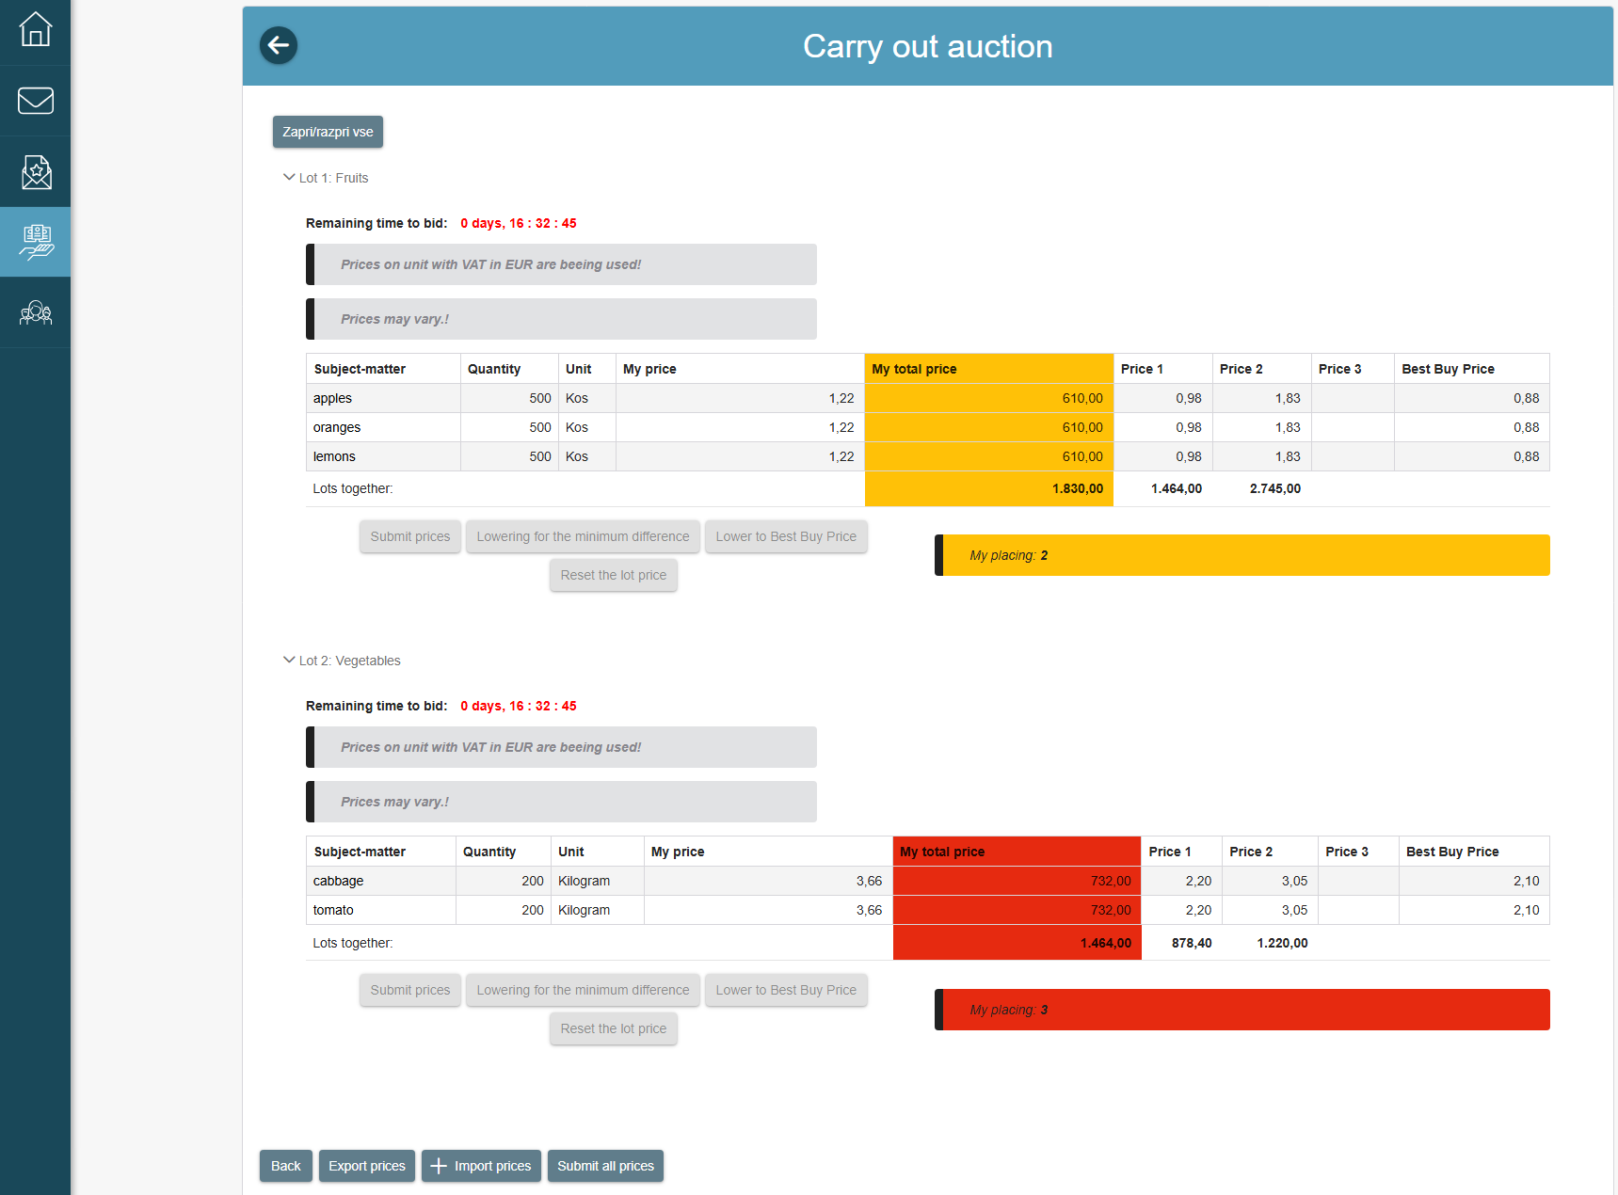
- Display of prices at the start of the auction

Actions during the implementation of the electronic auction
During the auction, the following options are available by means of which it is possible to submit your prices:
- Change of price by editing the table
Prices can be changed by clicking a cell in the line in which you want to change the price in the "My price/unit of measure" section and change the desired value.
Following the change in price, the "Submit prices" button will become active. Only when clicking on the button for individual item or lot (if the procurement is divided into lots) you will actually submit new prices. If the procurement is divided into lots, all prices may be submitted by clicking on the "Submit all prices" button located next to the buttons for the transfer of Excel templates.

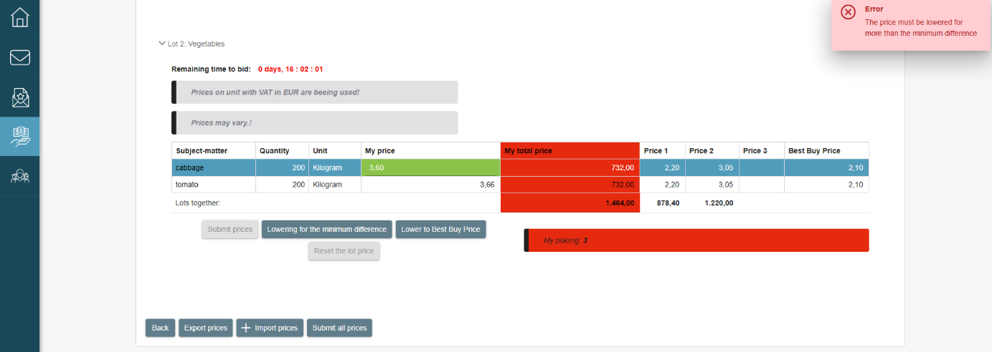
- Change of price by manual editing of the table
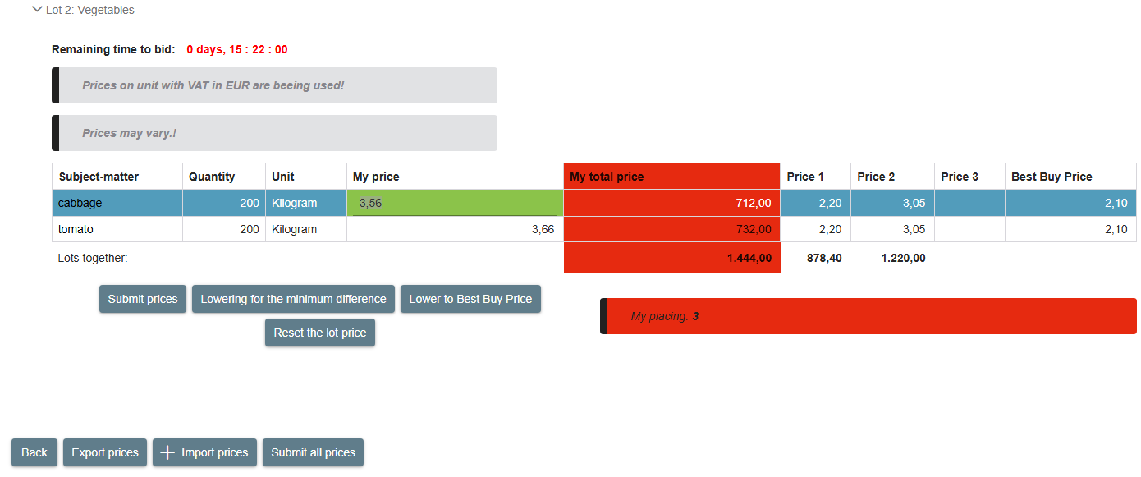

- Activity of the "Submit prices" button

- Change of price with the "Lowering for the minimum difference" action
This action is only enabled when the contracting authority enters a minimum step when determining the parameters of the auction. Prices can be changed by clicking on a cell in the line in which you want to change the price in the "My price/unit of measure" section or any other cell in the line and then clicking on the "Lowering for the minimum difference" button. The system will reduce the price of the item by a minimum step determined by the contracting authority in the procurement settings in the e-JN system.
Following the change in price, the "Submit prices" button will become active. Only when clicking on the button for individual item or lot (if the procurement is divided into lots) you will actually submit new prices. If the procurement is divided into lots, all prices may be submitted by clicking on the "Submit all prices" button located next to the buttons for the transfer of Excel templates.

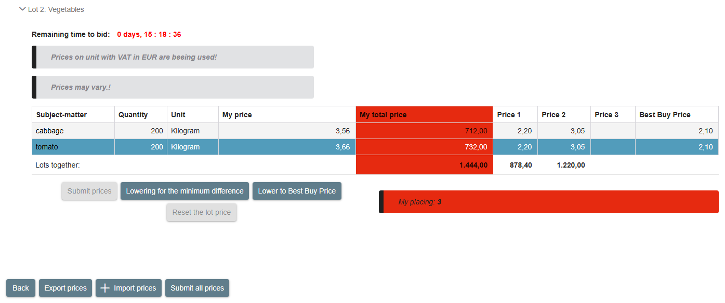

- Change in price by minimum step
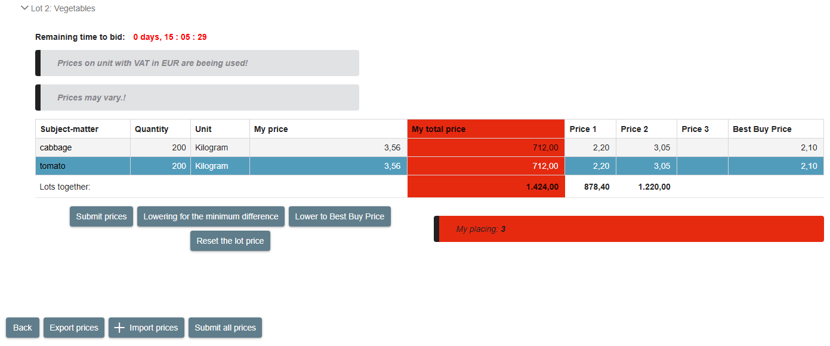
- Activity of the "Submit prices" button
- Change of price with the "BBP" action
This action is only enabled when the contracting authority enters a minimum step when determining the parameters of the auction. Prices can be changed by clicking on a cell in the line in which you want to change the price in the "My price/unit of measure" section or any other cell in the line and then clicking on the "Lower to Best Buy Price" button. The system will reduce the price of the item by a minimum step below the price of the lowest tender submitted in the system at the time when you started changing the price of the relevant item.
Following the change in price, the "Submit prices" button will become active. Only when clicking on the button for individual item or lot (if the procurement is divided into lots) you will actually submit new prices. If the procurement is divided into lots, all prices may be submitted by clicking on the "Submit all prices" button located next to the buttons for the transfer of Excel templates.

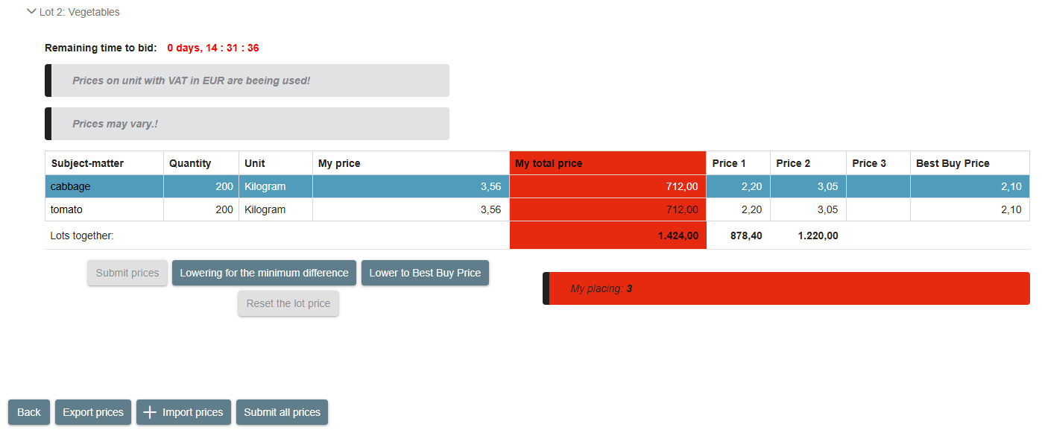
- Change in price by BBP
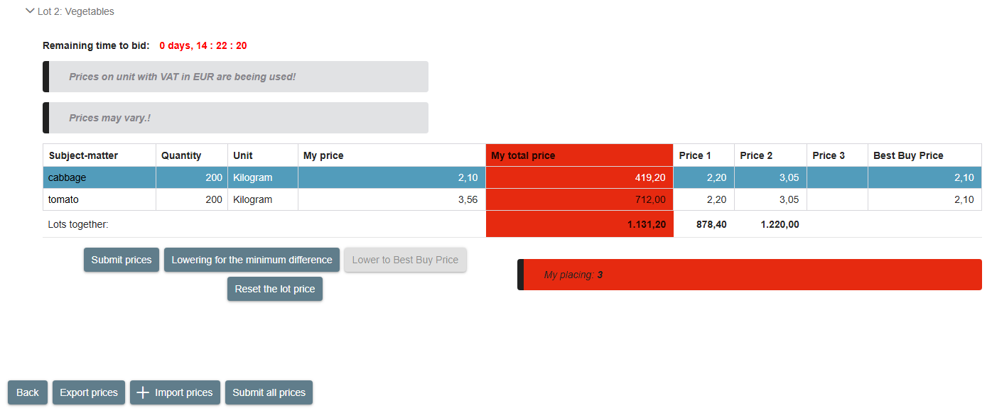
- Activity of the "Submit prices" button
- Change in price by importing "Excel template"
Prices can be changed by importing them with the help of the Excel table. First transfer the current prices in the Excel template, change the prices in the Excel and then upload this document in the e-Auction.
This may be done by using the "Export prices" and "+Import prices" buttons in the bottom of the table during the auction.
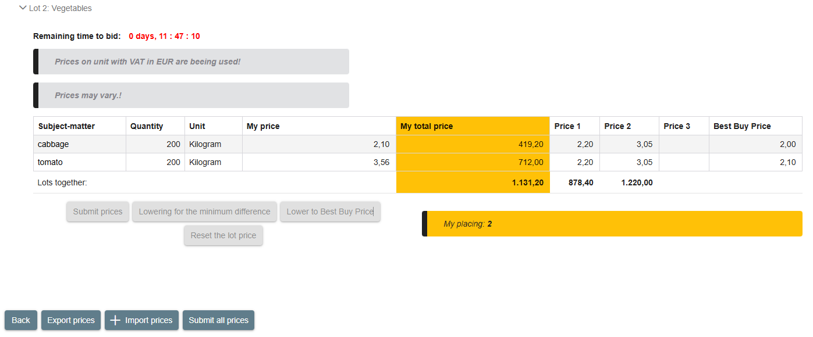
- Buttons for transferring Excel files
An example of an Excel file is presented below, which was exported from the system during the auction by using the "Export prices" button. It is only permitted to change cells in the "Price per unit of measurement" column in the template (table). If you wish to upload in the e-JN system the file in which another cell was changed, the e-JN system will not accept such file and will report an error.
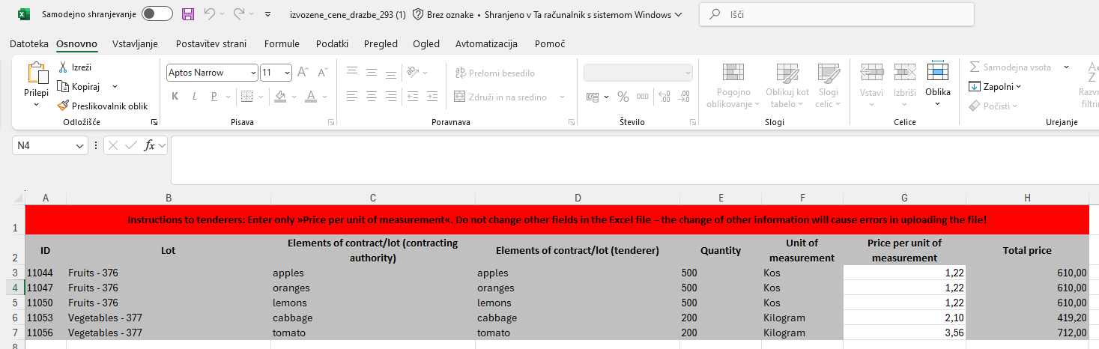
- Example of an Excel file following an export from the system before the change of prices
After successful import of the file with changed prices by using the "+ Import prices" button, the prices will be displayed, which you have prepared in the Excel file.
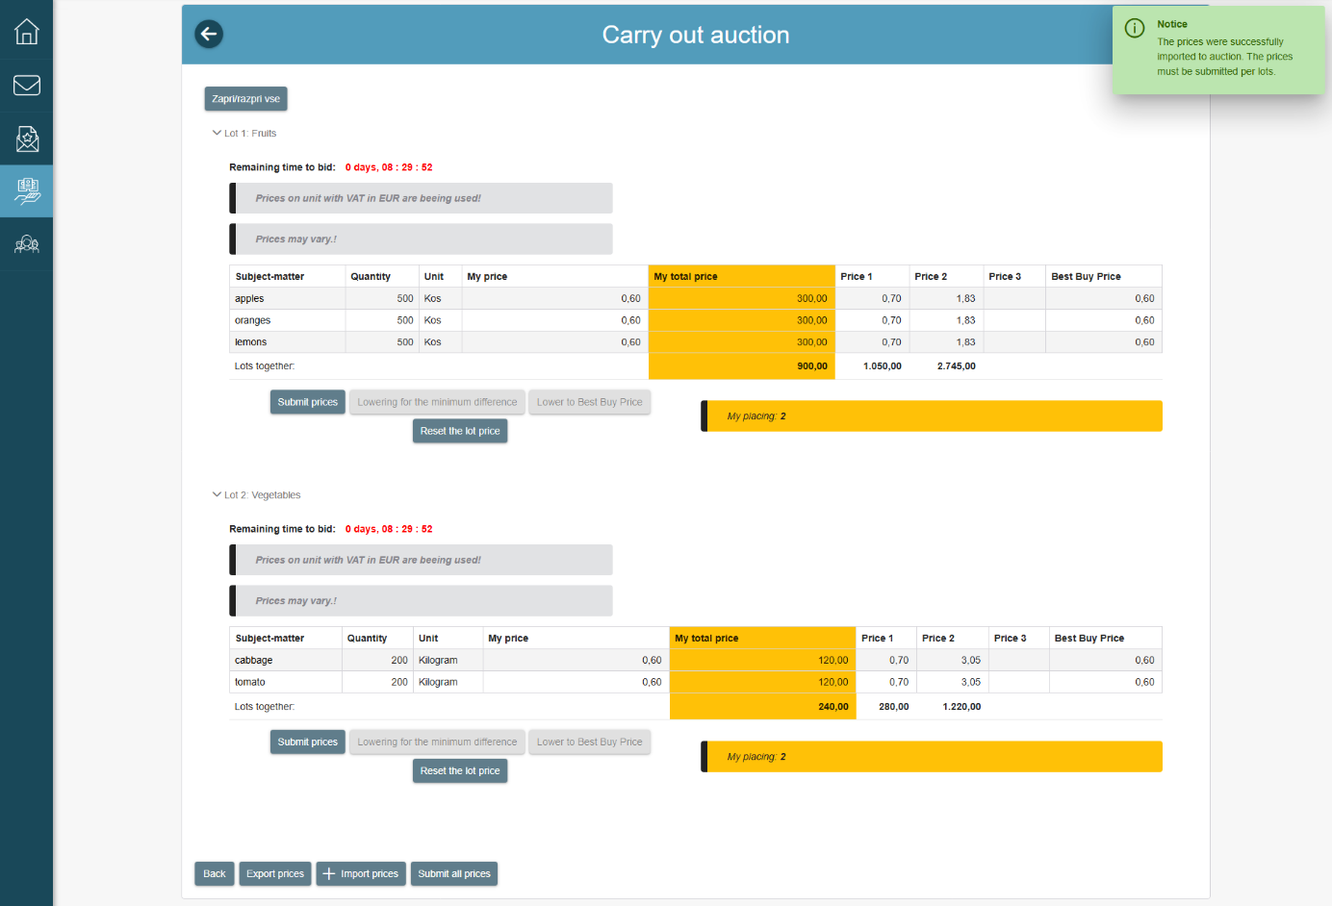
- Display of prices at the auction after successful import of the Excel file
Following the change in price, the "Submit prices" button will become active for all items or lots (if the procurement is divided into lots) where the change is active. Only when clicking on the button for individual item or lot (if the procurement is divided into lots) you will actually submit new prices. All prices may also be submitted by clicking on the "Submit all prices" button located next to the buttons for the transfer of Excel templates.

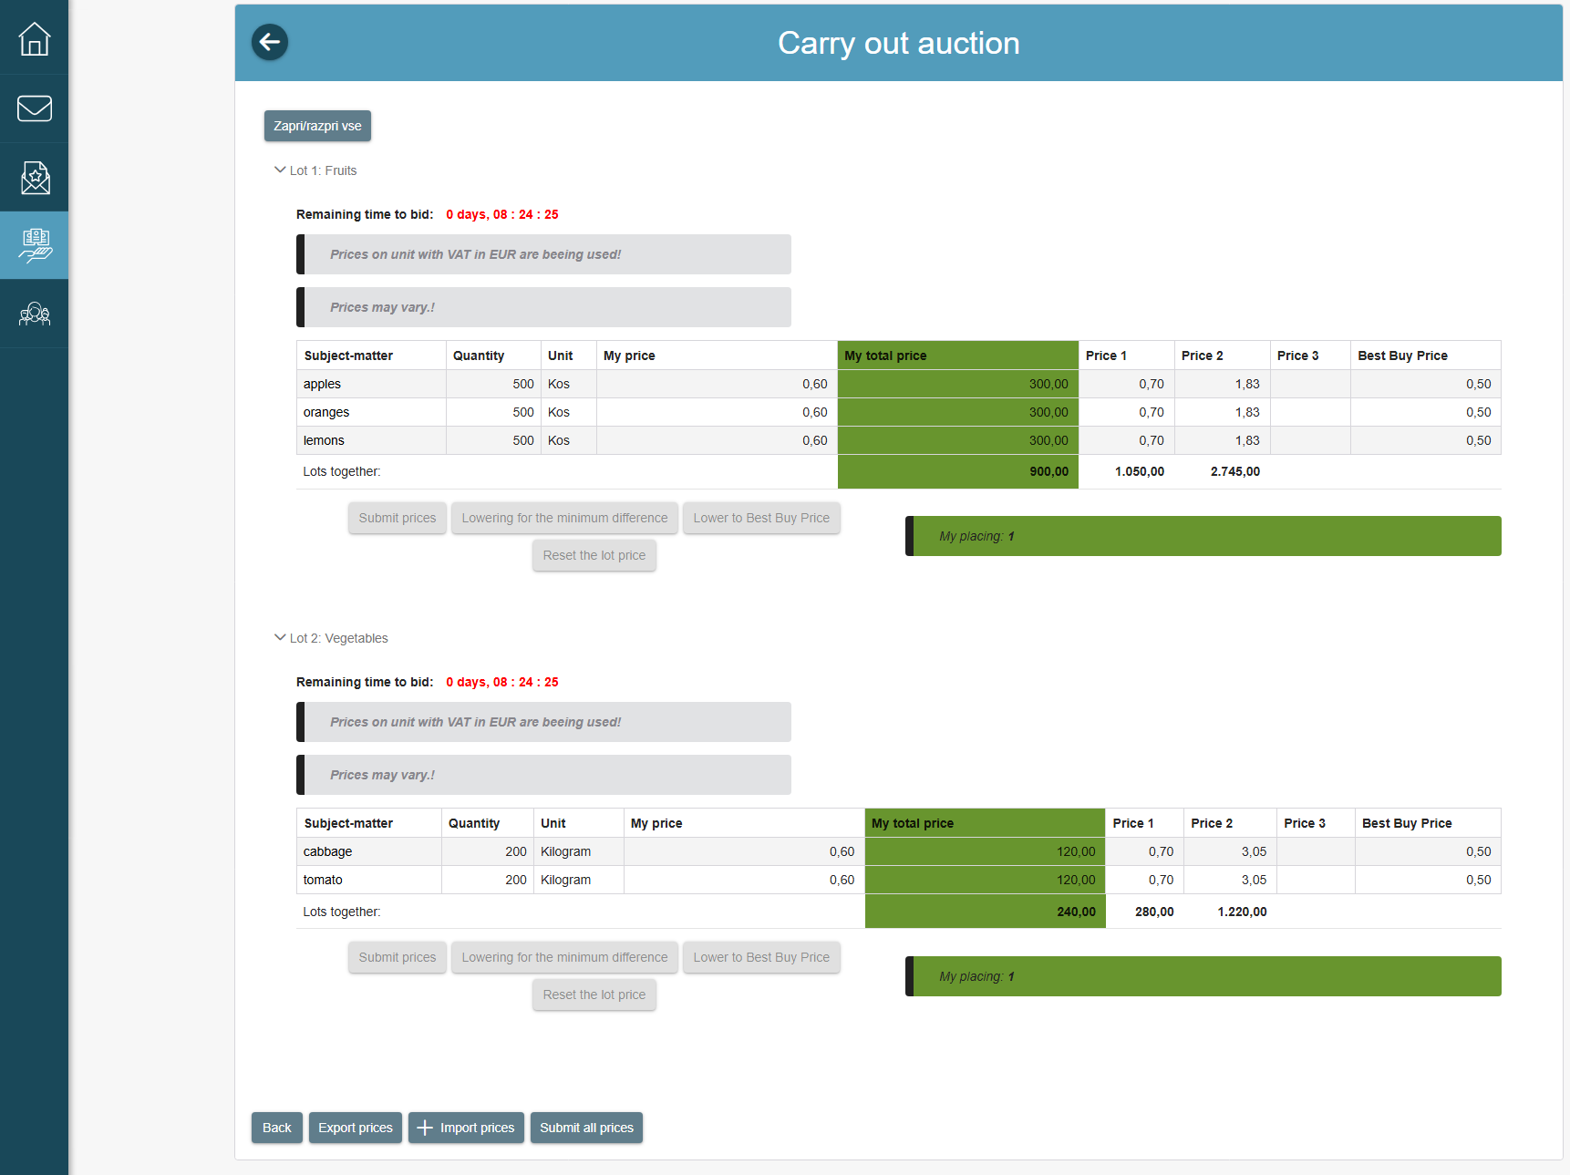
- Display of prices at the auction following the submission of changed prices with the use of the "Submit prices" or "Submit all prices" buttons

- Resetting the prices entered before the submission
Before the submission, the system enables you to change the prices for individual lots (or the entire procurement if there are no lots), which you have entered in one of the aforementioned ways, to the values that were last submitted in the system. This can be done by selecting the "Reset prices of the lot" button.
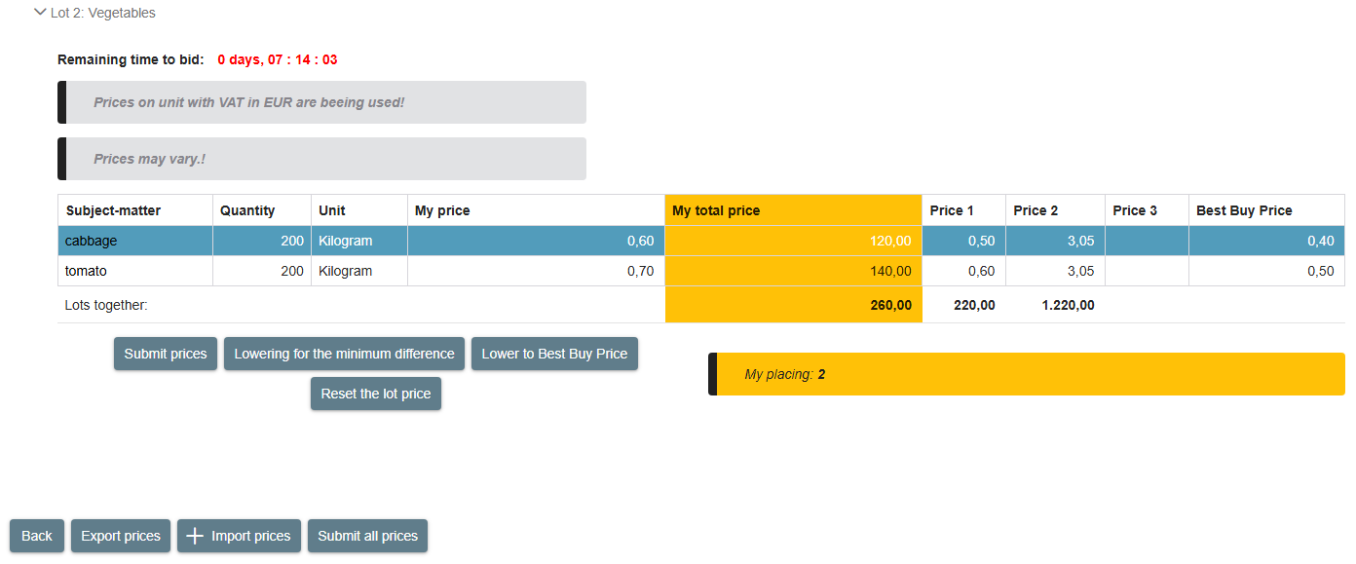
- Display of changed prices that were not submitted in the system before the reset
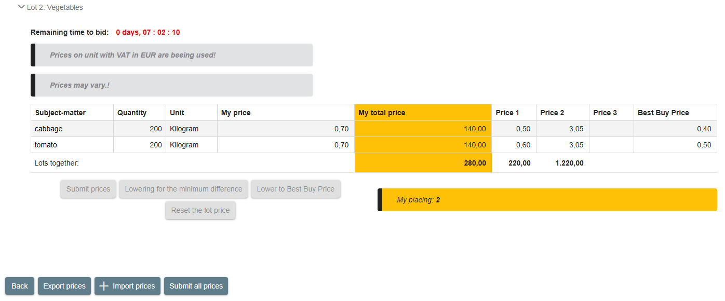
- Display of prices after the reset

The preparation of the tender (data entry and addition of documents) can be performed by only one user at a time. In the case of simultaneous editing of the tender by several users, the e-JN system does not guarantee the correctness of the entered data.

Explanation of individual fields and symbols displayed on the screen of the auction table
Before the start of the auction, your data transferred from the tender you submitted before the deadline for the submission of tenders can be found on the auction table.
During the auction, information about your placement (position) according to the criteria for the selection of the most favourable tenderer is accessible on the screen.
Explanation of tables:
- My price/unit of measure – represents the tender price for the item per the unit of measure (piece, m², etc.).
- My total price – represents the tender price for the item and the entire tender quantity.
- Price 1 ("Price 2", "Price 3") – represents the price of other participants (no more than three most favourable ones according to the criteria for the selection of the most favourable tenderer) for the item per the unit of measure (piece, m², etc.).
- Lot sum:
  - "My total price" column – total tender price for all items in the lot (or the entire procurement if there are no lots) for the entire quantity.
  - "Price 1" column ("Price 2", "Price 3") – total tender price for all items in the lot (or the entire procurement if there are no lots) for the entire quantity of other tenderers (no more than three most favourable ones according to the criteria for the selection of the most favourable tenderer).
Legend of colours:
GREEN – you offer the lowest price for the lot where your prices are GREEN.
YELLOW – you offer the second lowest price for the lot where your prices are YELLOW.
RED – you do not offer the lowest or the second lowest price for the lot where your prices are RED.
- Screen (table) display during the auction
In addition to the remaining time left in the interval, the current interval of the ongoing auction is also displayed on the top of the table in the case of the time-interval auction.
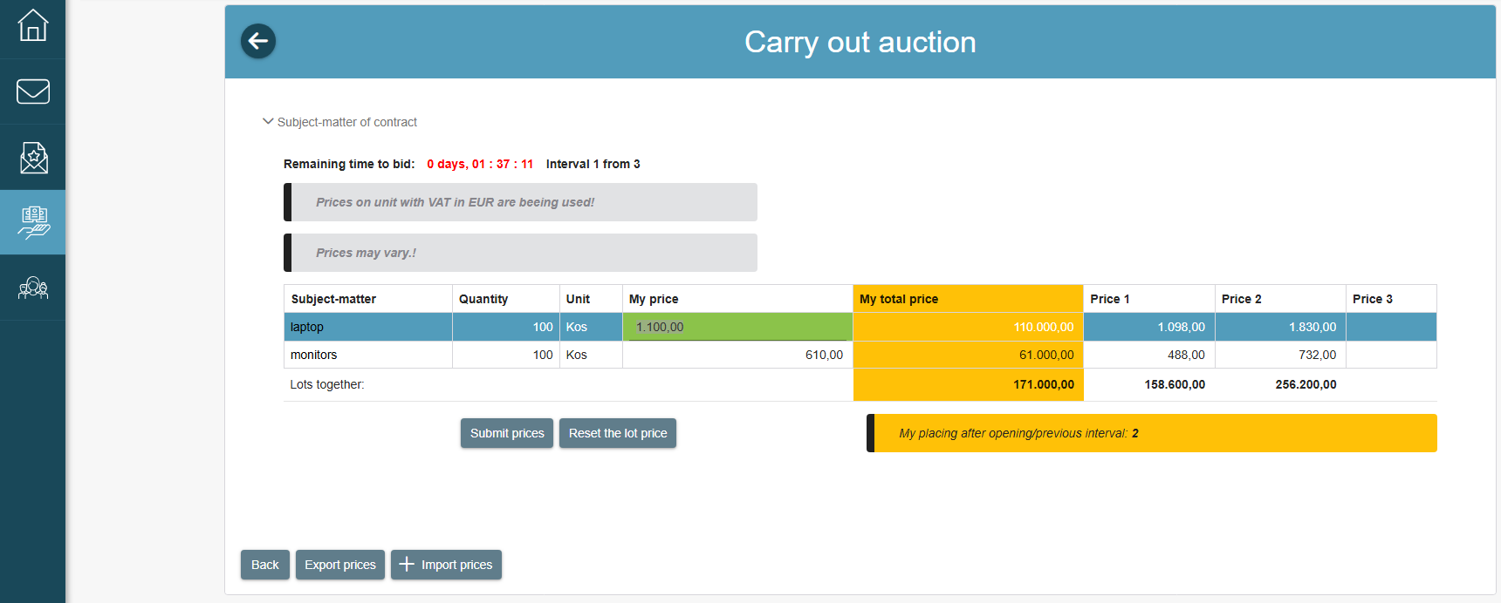
- Screen (table) display during the auction – time-interval auction
If the contracting authority suspended the implementation of the auction, a symbol will be displayed on the screen informing you of the suspension. The auction will continue once the contracting authority arranges continuation.
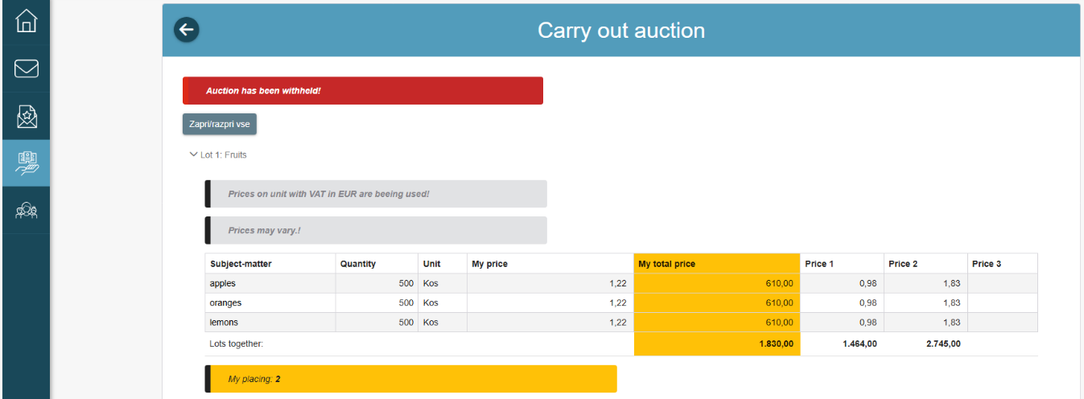
- Screen (table) display suspending the implementation of the auction – time-interval auction

Completed e-Auction
After the auction is completed, you will get access to the final prices of individual tenderers displayed along with their names.
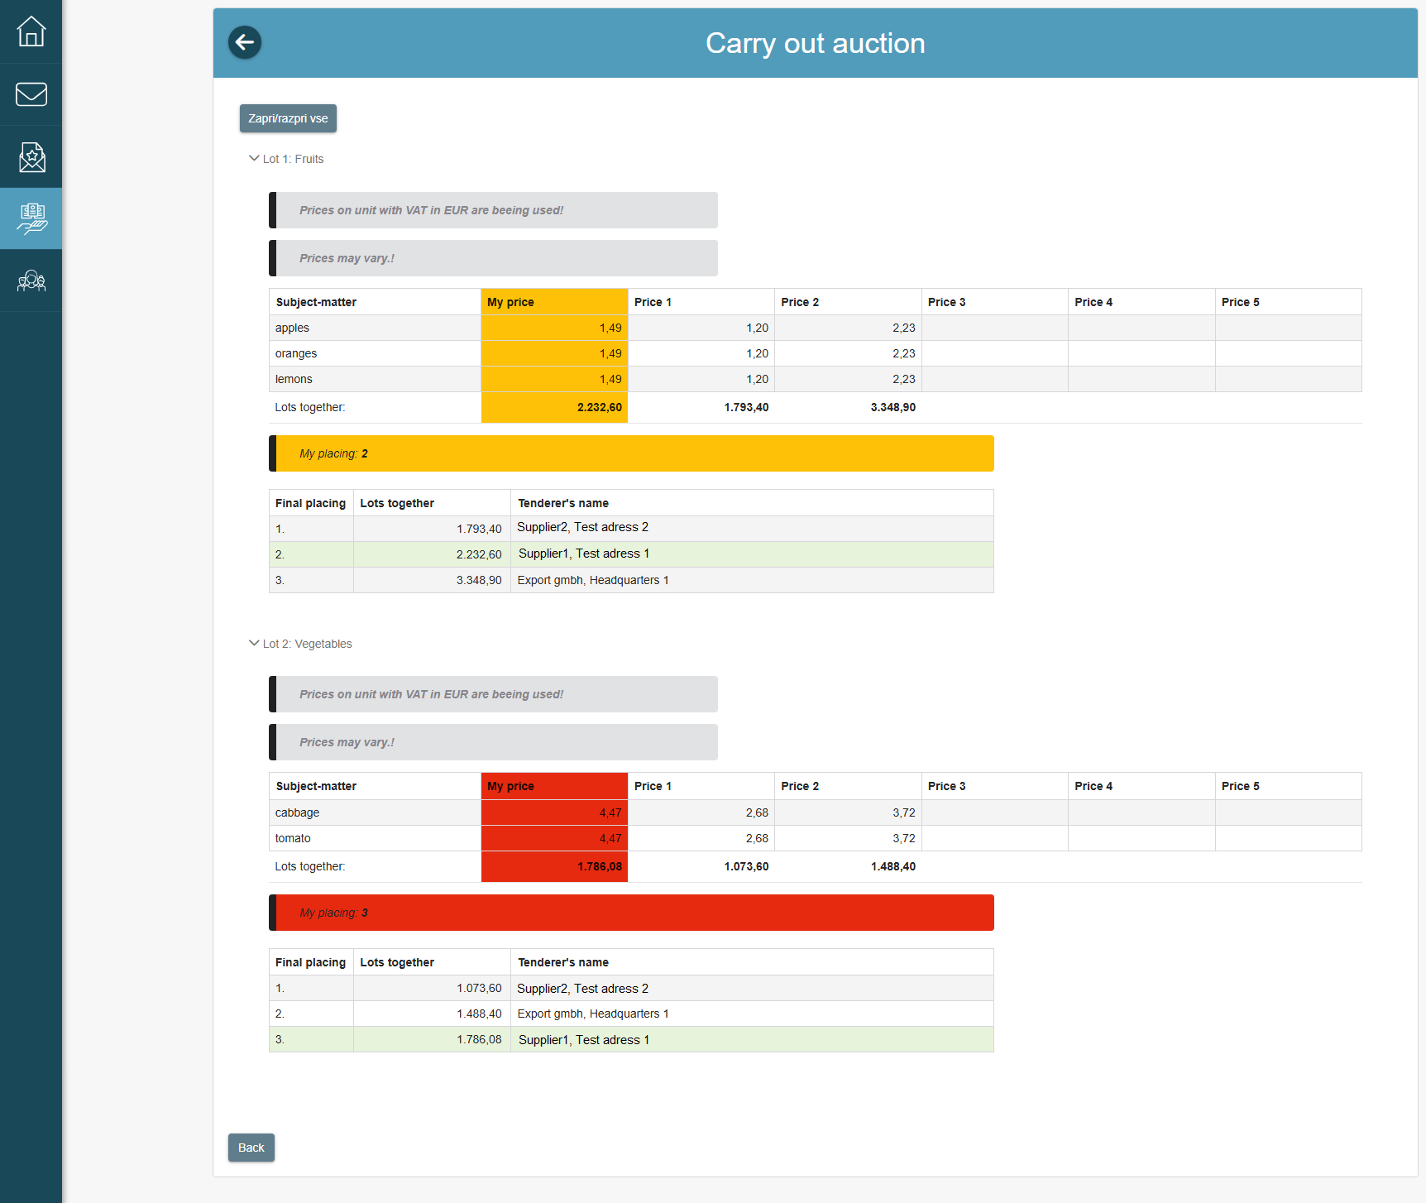
- Screen display after a completed auction
After the end of the e-Auction, the system will automatically prepare a pro-forma invoice of the tenderer, which the contracting authority accepts as a binding pro-forma invoice after the completed auction.

DYNAMIC PURCHASING SYSTEM
The e-JN system enables the implementation of a dynamic purchasing system (hereinafter: DPS). Participation in public procurement procedures implementing the DPS takes place in the same way as other procedures in the e-JN system.

Participation in the DPS
If you want to participate in a public procurement implementing the DPS, find the procurement in the e-JN system via the icon "Current public procurement" or via a web link on the Public Procurement Portal. The latter will redirect you to the e-JN system on the published DPS. The course of application for a public procurement implementing the DPS is the same as in two-phase procedures.
Selecting the public procurement, opens the page with the basic data of the public procurement (procurement details), the link to the Public Procurement Portal and (on the right hand side of the screen) the button "Participate in public procurement". By clicking on the button, the basic page "Application" will open, where you shall mark the category you are applying for, attach the necessary or required documentation and submit the application in the same way, as you do for other procedures in the e-JN system.

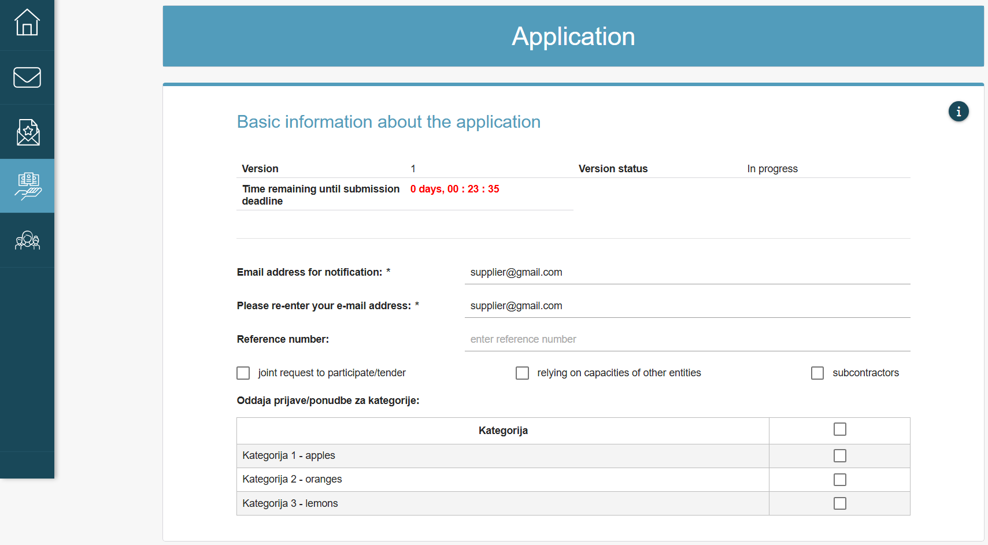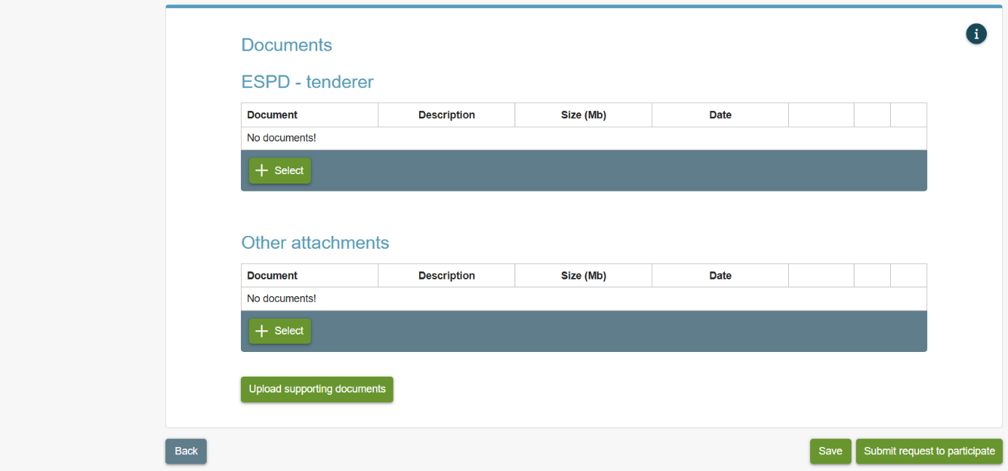
- Application

Subsequent application to DPS procedures
If the contracting authority for the public procurement implementing the DPS for one or more (or for all) categories did not request your qualification or you would like to participate in category you did not mark in the original application and applied for, you can apply again at any time in the future or you participate in the same public procurement implementing the DPS, when the contracting authority enables additional collection of applications.
This can be done in the same way as you submit your first application.

Request your qualification and specific procurements
After receiving your application for a public procurement implementing the DPS, the contracting authority will review the applications within the e-JN system and request your qualification (or not) for each category to participate in the second phase of the DPS (submission of a tender on the request of the contracting authority). The decision of request qualification must be published on the Public Procurement Portal, and the e-JN system will notify you of the request qualification by e-mail and/or via SMS messages and/or via the notification centre (depending on your notification method settings).
If request your qualification to participate in the second phase of DNS, you are included in the catalogue of tenderers of this DPS.

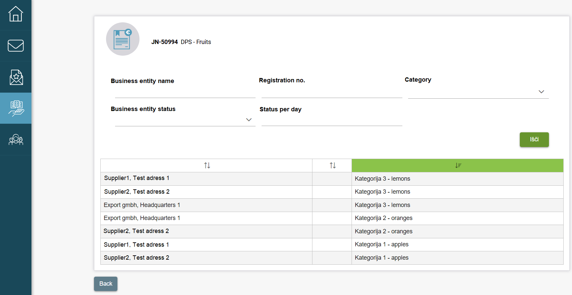
- Catalogue of tenderers
The catalogue of tenderers in the e-JN system can be find by selecting the "Tenders" icon and search for your submitted application for the public procurement implementing the DPS in the "List of applications/tenders".

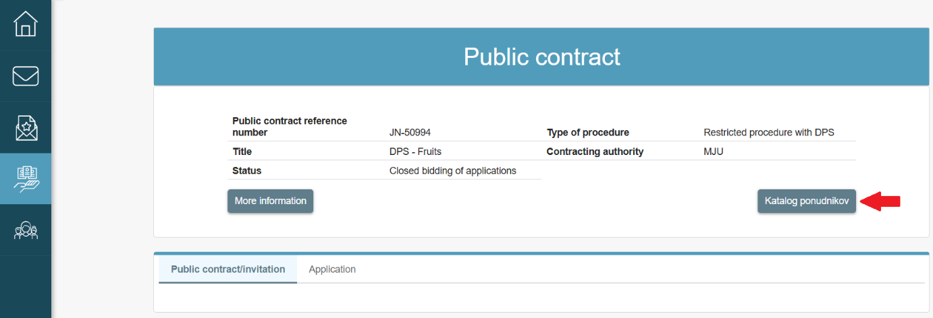
- Application

Participation in specific procurements of the DPS (second phase)
In the case described in point 8.3, when the contracting authority has requested your qualification, you will be able to participate in the second phase of DPS (submission of a tender on the request of the contracting authority). When the contracting authority creates a request for DPS in the e-JN system, you will receive an invitation for tender submission for each category the contracting authority is submitting a request. You will receive the invitation via e-mail. The invitation can also be seen among the invitations ("Invitations" icon).
The submission of the tender takes place in the same way as for other procedures in the e-JN system.

Verification of qualification to participate in the DPS
In accordance with the paragraph 10 of Article 49 of the Public Procurement Act (PPA-3), the contracting authorities may, at any time during the period of validity of the DNS, require admitted participants (or from all participants in the case of joint procurement, when the economic operator rely on the capacities of other entities, or when the contract involves a subcontractors) to submit a renewed and updated ESDP within five working days from the date on which that request is transmitted. At any time during the period the DPS, the contracting authority can ask you to submit a new ESPD form to check whether you are still qualified to participate in each DNS and/or its category. You will receive a notification to submit a renewed and updated ESDP from the e-JN system by e-mail. You can also find it by clicking on the "Tenders" icon, where you can find your submitted application for the public procurement implementing the DPS in the "List of applications/tenders", similar to invitation for supplementing the request to participate.

INFORMATION AND NOTIFICATION CENTER
The notification functionality enables easier review of notifications and tasks within the e-JN system.

You have an option on how you want to receive notifications - you can receive notifications via e-mail and/or via SMS messages and/or via the notification centre. You can edit the notification settings via the user profile → Edit contact information, where you have three parts available:
• “Personal info”,
• “Notification” and
• “CPV notification codes”.
In the “Personal info” section, you can specify or change the notification email address, notification phone number and notification language for SMS messages.
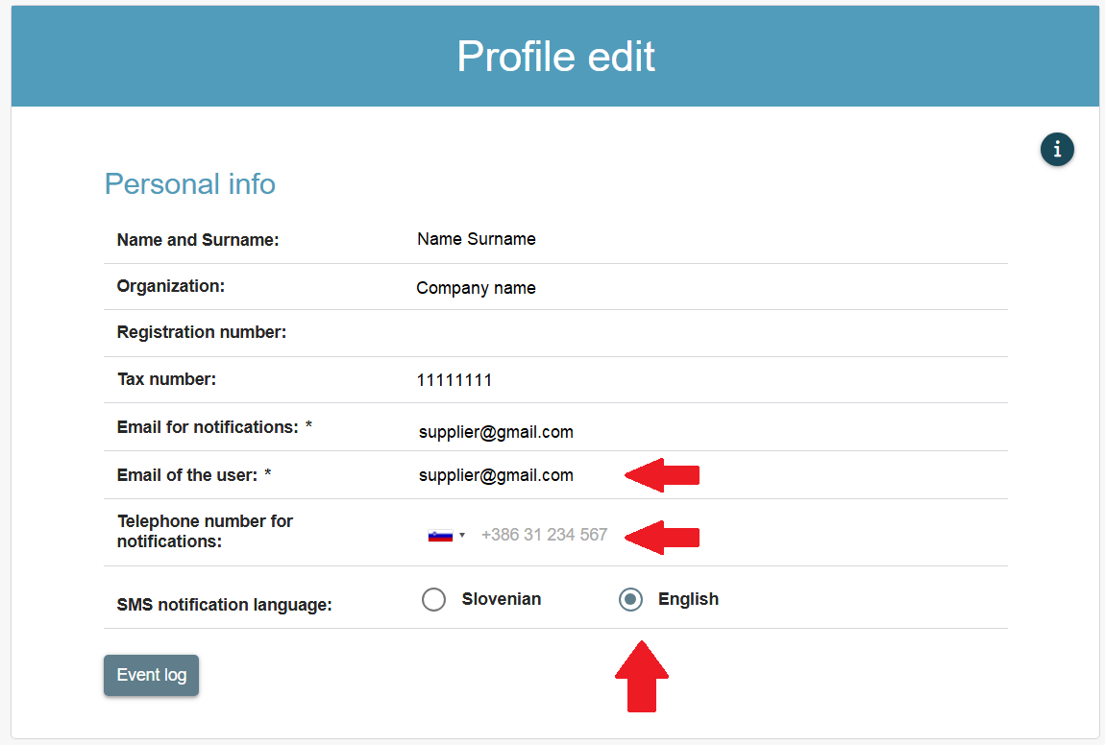
- View profile editing setting in the “Profile edit” section
In the "Notification" section, check the options you want to be notified about.
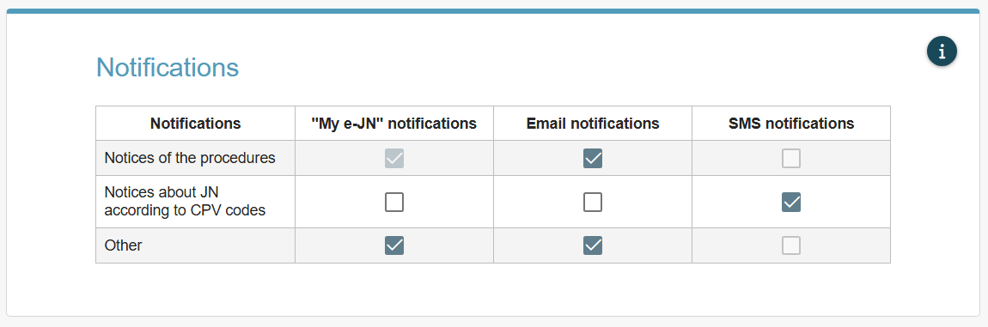
- View profile editing setting in the “Notifications” section
The "CPV notification
codes" section is intended for notification of newly published public procurement procurements in the e-JN system based on the CPV code of the public procurement that you specify in this section for notification.
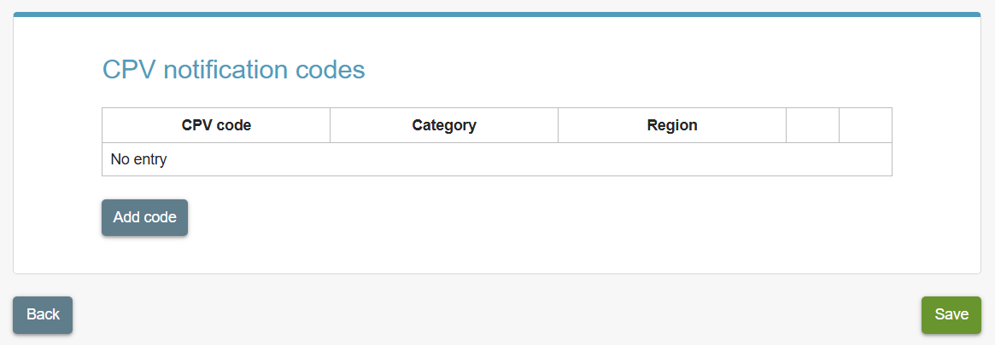
- View profile editing settings in the “CPV notification codes” section

Notification centre
The notification center is shown with:
- an envelope icon. The number displayed next to the icon represents the number of unread notifications,

- An envelope icon with the number of unread messages

- a "Notifications" icon. After logging in to the e-JN system, the "My e-JN" desktop will appear.
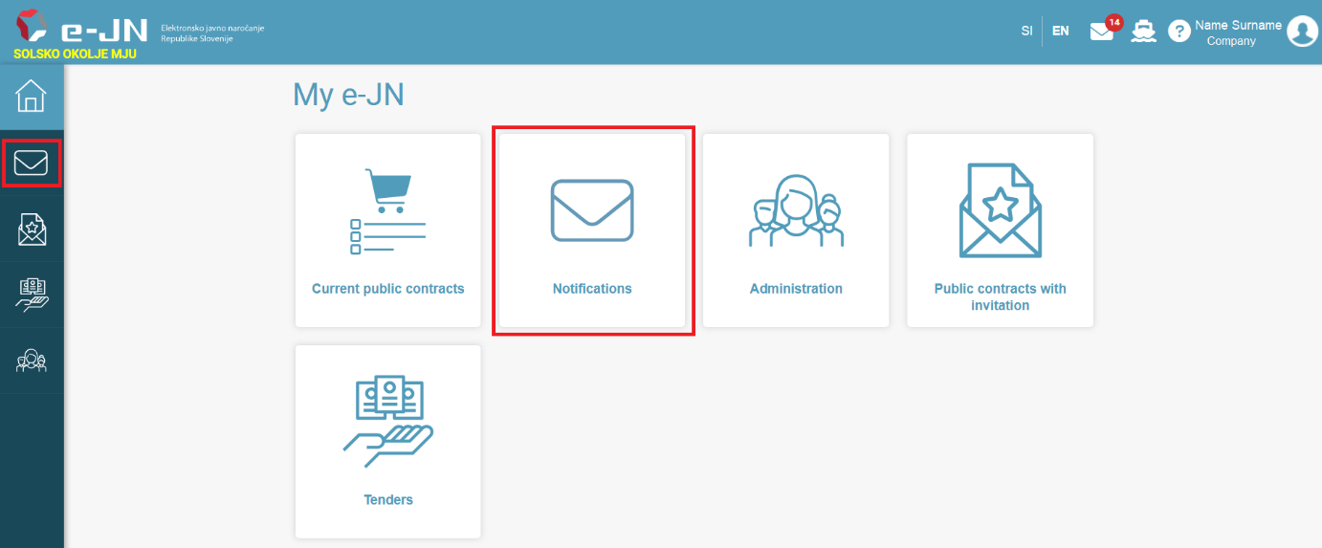
- A “Notifications” icon

Selecting the icon  opens the screen to display the list of unread notifications shown in the image below. By selecting on the notification, it is marked as read and is removed from the list, while the number representing the number of unread notifications is reduced.
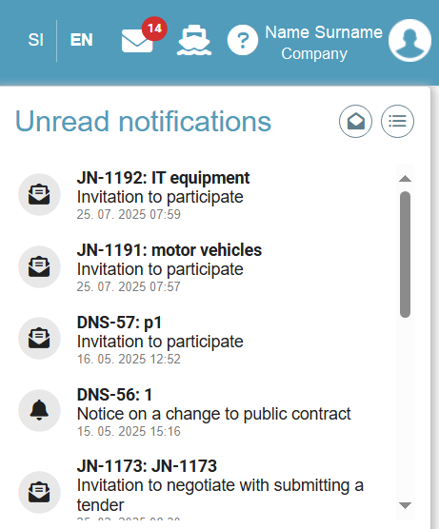
- A list of unread notifications
By clicking on the icon  all notifications are removed from the list of unread notifications. By clicking on the icon  you are redirected to the "Notifications" page, which can also be accessed after logging in to the e-JN system by selecting the "Notifications" icon on the "My e-JN" desktop.
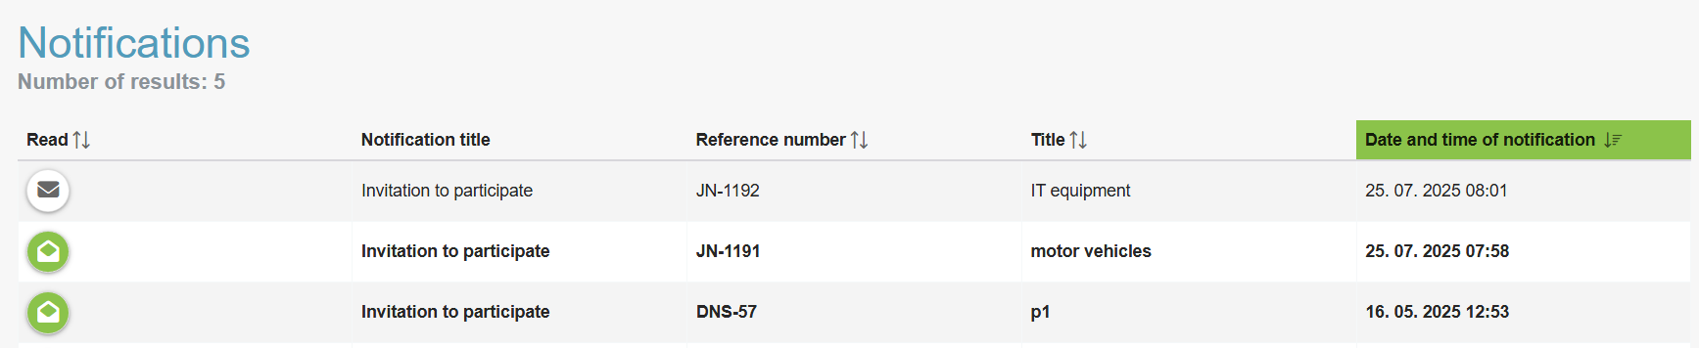
- A list of notifications
The  icon shows unread notifications and the icon  shows read notifications. By clicking on an individual notification, you are redirected to the notification details screen or to the specific task, if the notification is a task.

FAQ
Answers to frequently asked questions.
- Important recommendations

When preparing tenders, the tenderer’s attention is drawn to the following options and specifics of the e-JN system:

- Make sure you start preparing and submitting your tender on time.
- When submitting tenders, the size of files is limited to 500 MB per file and 1,5 GB for the entire tender documentation (all files in total).
- When naming pro-forma invoices, ESPDs and Statements, avoid using sibilants and special symbols to prevent unpredictable problems. We advise the use of the following symbols: a–z; A–Z; 0–9; -; _; .
- After the upgrade of the electronic public procurement portal (e-JN or ejn.gov.si), the uploading of the following files was made possible (zip, xls, xlsx, docx, doc, pdf, xml, jpg, jpeg, png, tif, tiff, rtf).
- The uploading of other formats is done as follows:
- the files must first be archived in the zip file. To this end, you can use the functionality in the Windows system or use the tools for archiving (WinZip, 7-Zip, etc.). To avoid excessively large files, we recommend that the attached documents are scanned in black and white with 150dpi resolution.
- In the case of a large number of files that you intend to upload to the "Documents" section, "Other attachments" section, we suggest that you compress the files into a *.zip file and then upload it to the "Other attachments" section. With this action you will avoid the problems of uploading a large number of files to the e-JN system.
- The SI-PASS https://sicas.gov.si/CES-Sign/sign/sign.htm enables electronic signing of the ESPD forms for other participants (partners, subcontractors). The tenderer (or the leading partner if a group of tenderers acts as a tenderer) signs their own ESPD when submitting the tender.
- Observe the contracting authority’s instructions for the preparation of the tender, especially the pro-forma invoice. We also point out that the entered total tender value and the document uploaded in the "Pro-forma invoice" section are accessible at the public opening of tenders, which is why they should not contain data that could reveal personal information, classified information or business secrets.
- If you encounter a problem or the message: "You do not have sufficient rights to access the content of the website!" in previously working web application, it may be due to stored cookies or browser data. To solve the problem, please follow these steps:
1. Open the browser settings (e.g. Chrome, Firefox, Edge) by clicking on ctrl+shift+delete.
2. Select the option "Clear browsing data".
3. Under the option "Time range", select "All time".
4. Check the following options:
- Cookies and other site data
- Cached images and files
5. Click "Clear data".
6. Close and restart the browser.
7. Try accessing the application again.
- The use of Internet Explorer is no longer supported. When using this browser in the e-JN system problems may occur, which are outside control and responsibility of the e-JN system administrator and the registered user (e.g. failure of all system functionalities or individual sections of the system). Internet Explorer was replaced by the new internet browser, Microsoft Edge.

