Registration to e-JN information system (hereinafter: e-JN system) for a “Company registered outside Slovenia”
Registration to the SI-PASS system is needed before you can successfully register to the e-JN system.
IMPORTANT: In addition that we support qualified EU certificates, we also support the certificates from the list https://ccadb-public.secure.force.com/mozilla/CACertificatesInFirefoxReport and EU cross-border authentication in accordance with the eIDAS regulation.

Registration procedure:
- In the e-JN system click on the button »Register« on the icon »Are you a tenderer?«
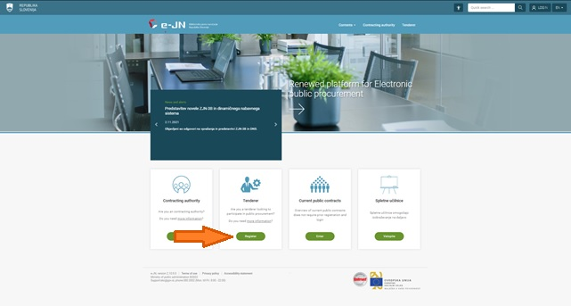

- You will be redirected to a SI-PASS system. In a left bottom corner, you can change a language to English.
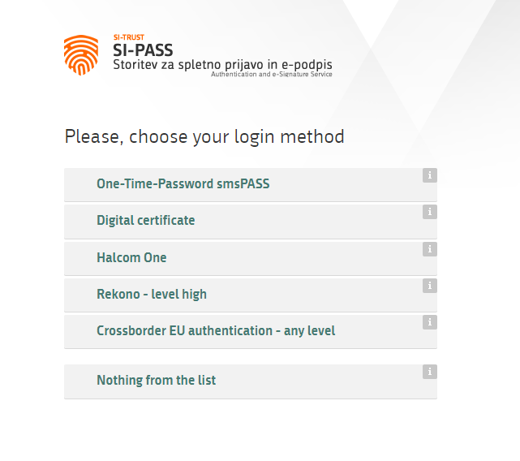

If you are using digital certificate, follow steps 3a and 3b.

If you are using EU cross-border authentication in accordance with the eIDAS regulation, follow steps 4a and 4b.

3a. If you are using a digital certificate, select “Digital certificate” from a list.
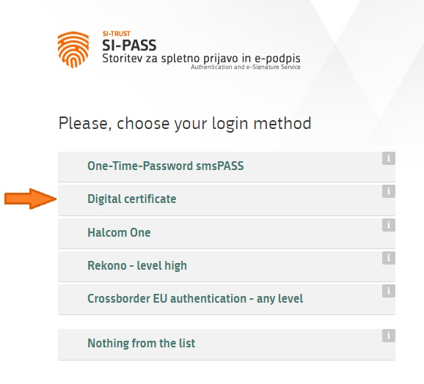

3b. The browser will offer you a list of your digital certificates; choose the one with which you wish to register and click “OK”. Continue with step 5.
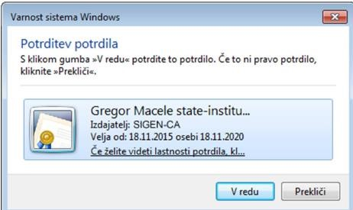

4a. If you are using EU cross-border authentication in accordance with the eIDAS regulation, select »Crossborder EU authentication – any level«. From a drop-down list, find your country and click confirm.
Depends on which country you select, you will then be redirected to your country’s web page for online authentication for online services of European Union member states. Proceed with their authentication steps.

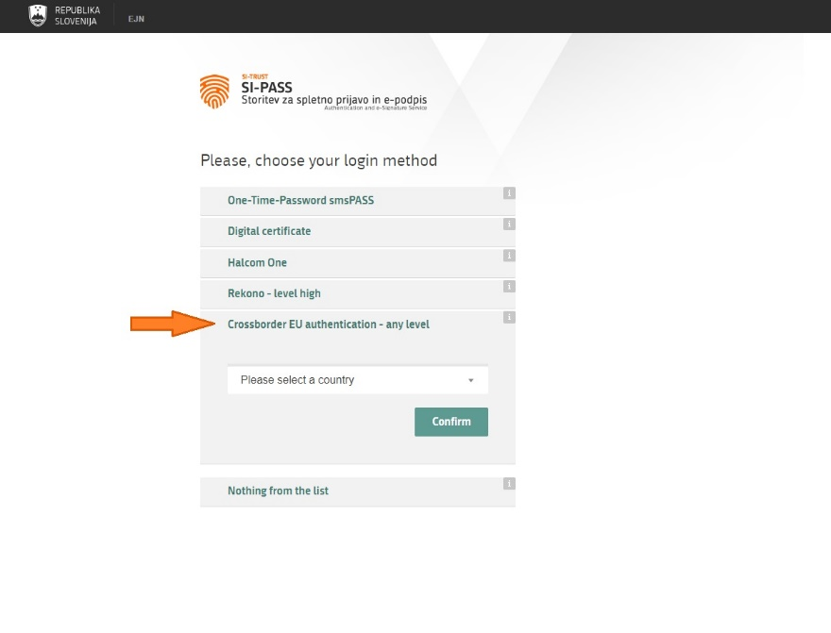
4b. After you successfully complete authentication, you are again redirected to SI-PASS, where you proceed with login or registration.

- You will be redirected to the page “Login”. If you are not yet a registered user of the SI-PASS system, click “New user”.

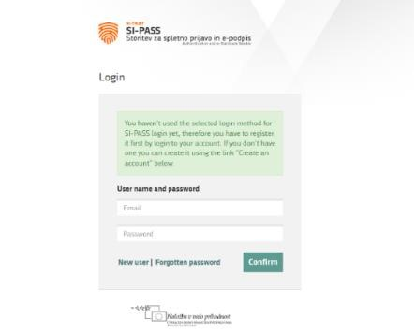

- A new page “Registration” will open. You need to enter your login information: email address, password, security question and answer, and security code. Read the Terms of Use and select the box, confirming that you accept the terms of use. Continue by clicking “Confirm”.
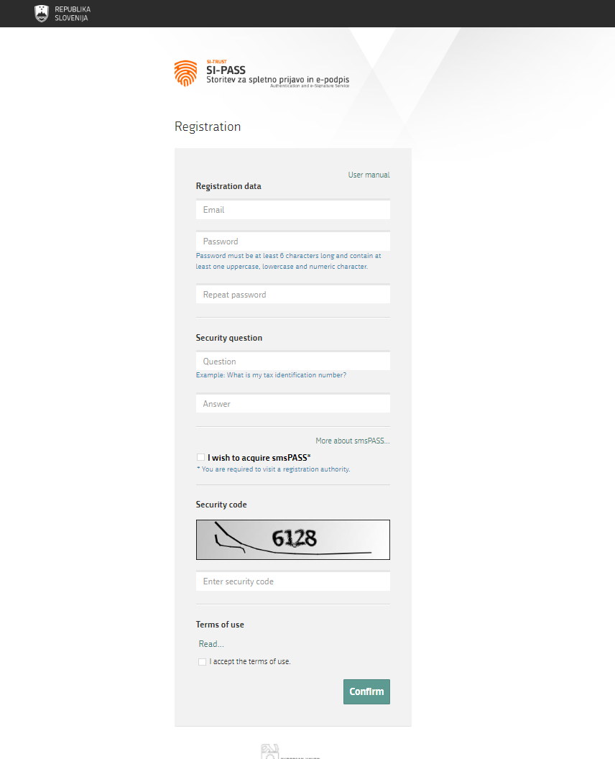

- After successfully entering and confirming the registration information of your user account, a page with further instructions will appear. Close the window by clicking “Close”.
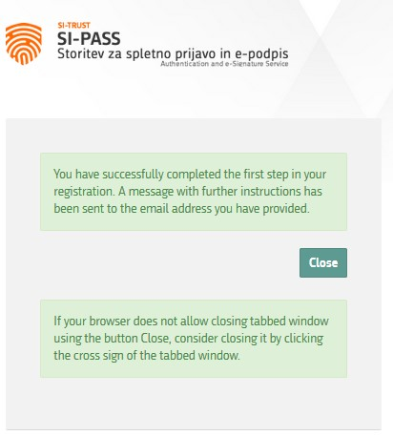

- You will receive an email for the conformation of the registration of your user account. Click the highlighted text “Click to confirm” in the e-mail.
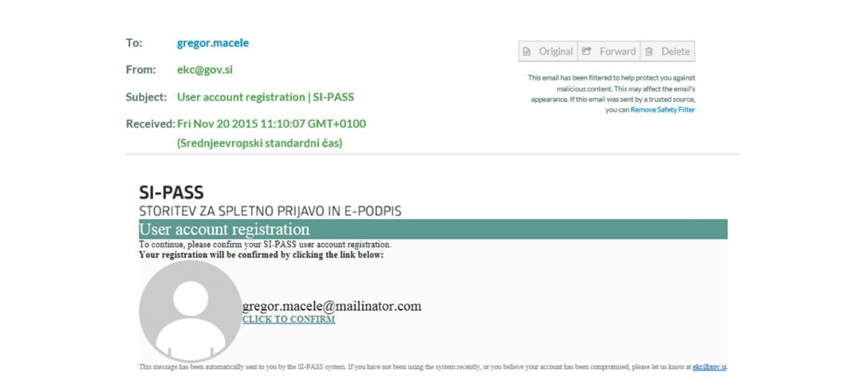

- You will be redirected to the page “Continue registration”. Enter your email address and password, which you have entered upon registering, and click “Continue”.
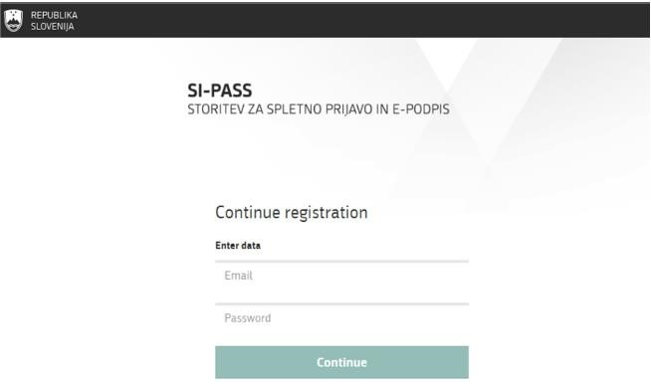

- After successfully entering your email address and password, a window appears, notifying you that the registration of your user account was successful. Close the window by clicking “Close”.
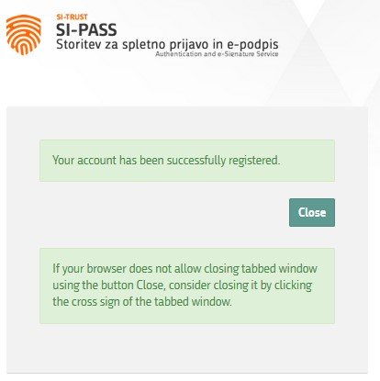

- You will receive an email confirming your registration.

- After successfully registering your user account at SI-PASS, you can continue with the login process in the e-JN system.

- Once again click on the button »Register« on the icon »Are you a tenderer? « (as in step 1). You will be redirected to the SI-PASS login page. Enter your username respectively email address and password, you have entered upon registering.
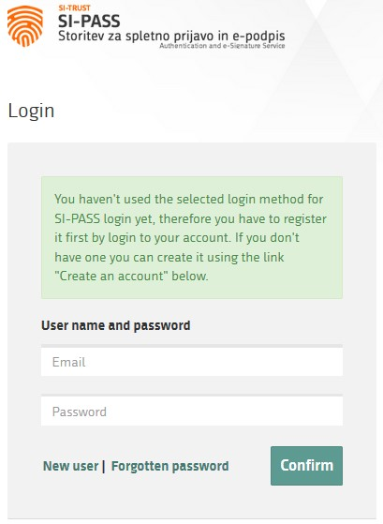

- After clicking “Confirm”, the system will begin with the login process and start gathering all information needed for the use of the application of the provider.
A window containing personal information which will be transmitted to the provider (i.e., system e-JN) will open.
If you do not wish for this window to come up every time you log in, select “I agree that this information will always be transmitted to the service provider.
The system does not demand you to fill in the data you do not have, e.g., SI VAT number. Click “Confirm” and you will be redirected back to the e-JN system.

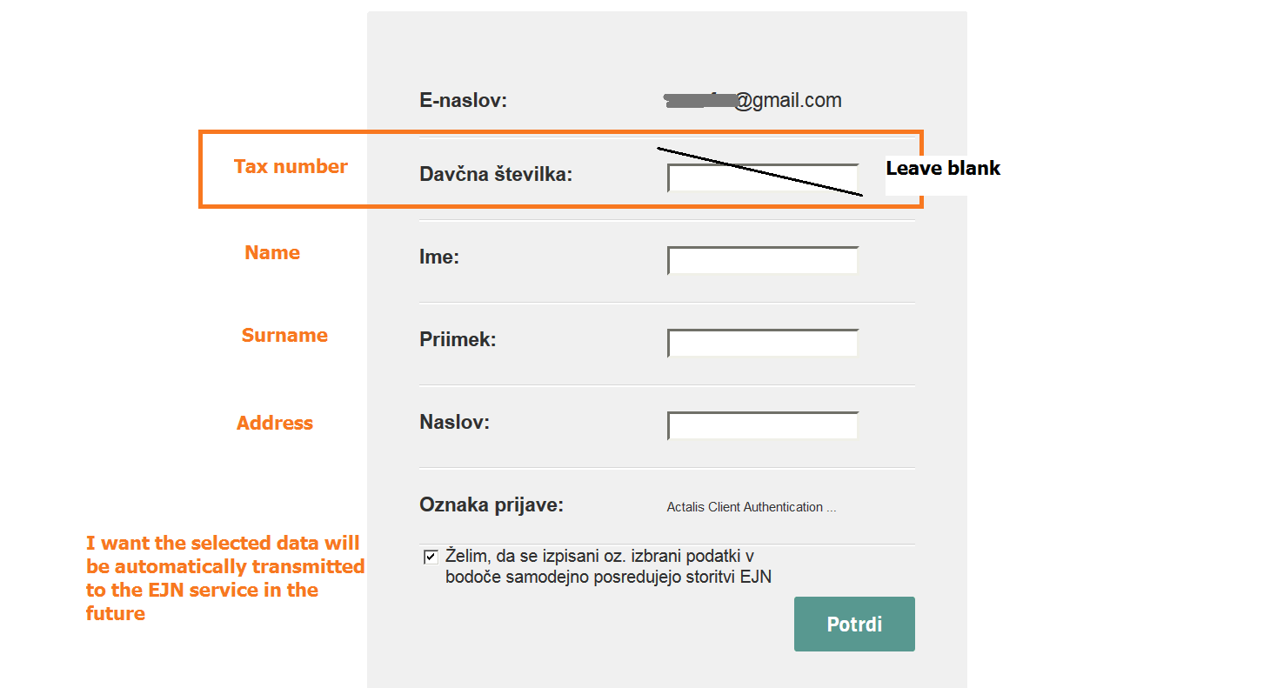

- Before using the e-JN system you must first agree to its General Terms and Conditions.
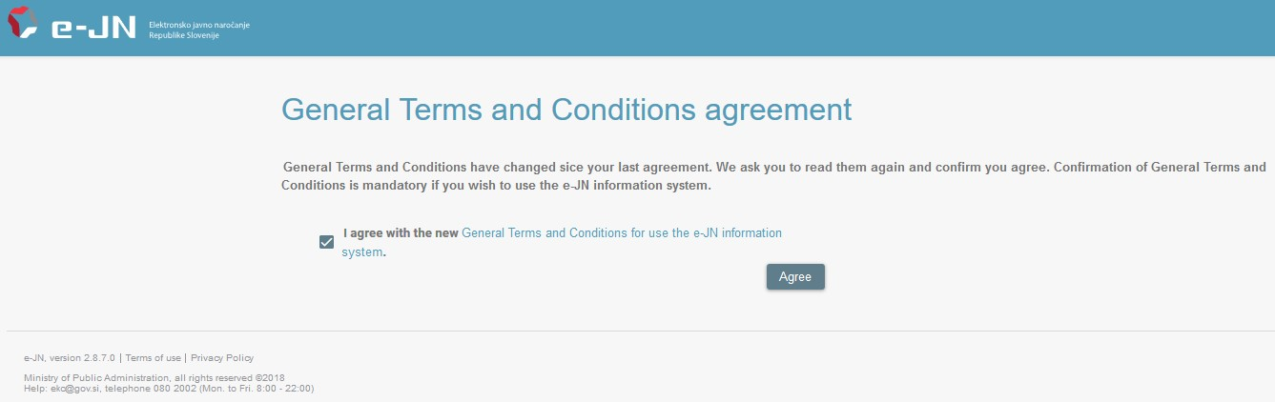

- Select the option “Company registered outside Slovenia”.
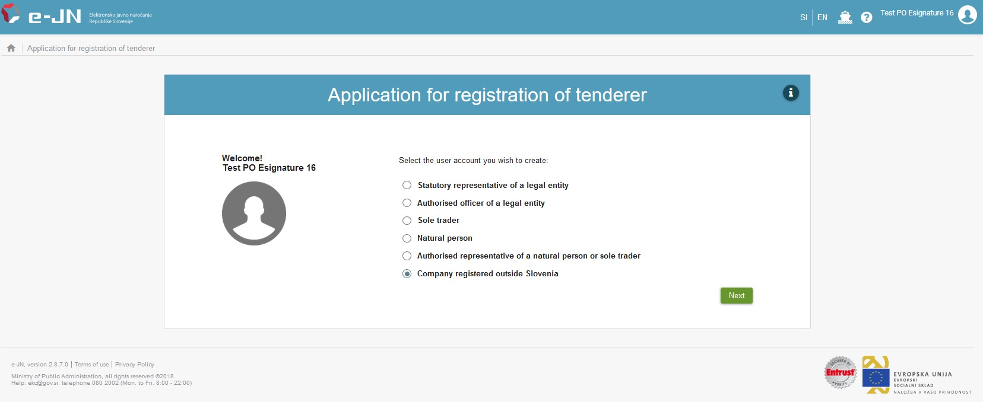

- Enter the company identifier, then click on “Search”.
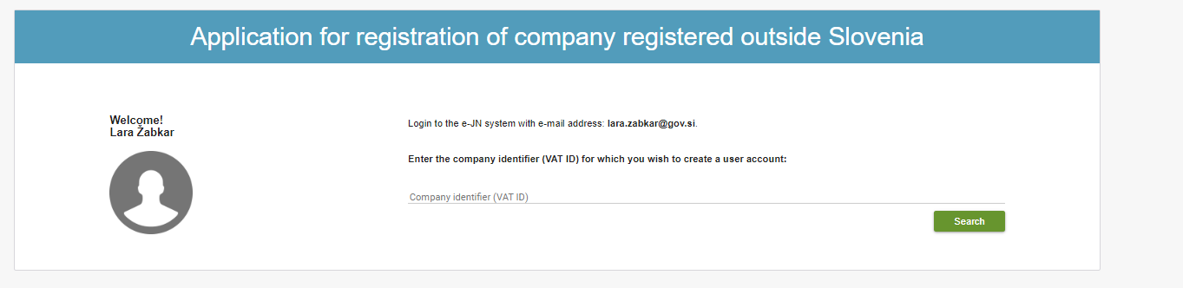

- Fill in your information (first name, family name, e-mail address, address, telephone number).
Fill in the company information (company name and address).
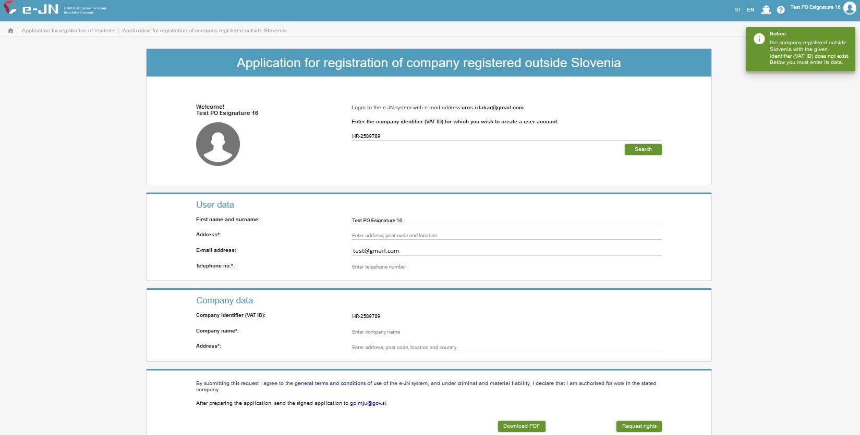

- Check that the information shown is correct and also check the General Terms and Conditions.

- By firstly clicking on “Download PDF” button, you download a registration form, which you need to fill it, sign it, and send it to gp.mju@gov.si.
If you forget to click “Download PDF” button, the authorisation is available here: https://ejn.gov.si/en/dam/jcr:cee48514-d72e-418c-acc8-d238714000f9/ejn_registration_form.pdf.
.

- Finish an electronic registration by clicking on “Request rights”.

The main administrator of the e-JN system must now verify your application and confirm your rights. You will be notified by e-mail of the successful confirmation of your rights, and then you can start using the e-JN system.
The administrator confirms the rights no later than at the end of the next working day, following the day when the user requested the rights (see General Terms and Conditions).

In case of difficulties with registration, you can contact a technical support, available at ekc@gov.si or +386 1 478 8590.

System SI-PASS supports qualified EU certificates, certificates from the list Mozilla list.

