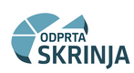

INSTRUCTIONS FOR USE OF THE SKRINJA INFORMATION SYSTEM
AWARDED PUBLIC PROCUREMENT IN SLOVENIA

Ljubljana, January 2026

TABLE OF CONTENTS
1. Introduction 3
2. Data filtering 3
3. Data interaction 5
4. Overview of the selected filters 6
5. In-cloud tips 7
6. Data export 7
7. Other functionalities 8
7.1. Show as a table 8
7.2. Focus mode 8
7.3. Data sorting 9
7.4. Link to the contract award notice on the Public Procurement Portal 9

Introduction
The Skrinja information system for awarded public procurement in Slovenia, is a single-entry website, accessible at https://ejn.gov.si/skrinja/skrinjaeng.html. The system is created as a report intended for public use. The report in the so-called objects (tables, graphs) shows data on awarded public contracts in Slovenia. The data is collected from the contract award notices which are publicly posted on the Public Procurement Portal of Slovenia (https://www.enarocanje.si) from 1 January 2017 onwards. The data is updated daily with the publication of contract award notices from the previous day. Each contract award notice is its own process, which can be split into multiple sets or orders. If the contract was awarded to multiple contractors (in the case of a joint bid, subcontracting, or use of the capacity of other entities), the value of the contract is evenly distributed among the contractors.
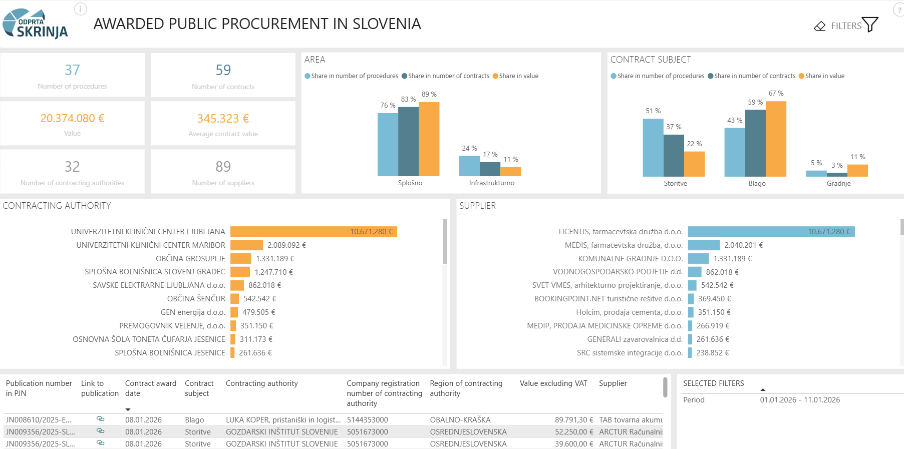

Data filtering
When accessing the website or report, the system displays default data on public procurement in Slovenia from January 1 of the current year to the day before the data was accessed. To change the date frame, you must click on the icon in the upper-right corner “FILTERS” 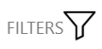.

The report has the “Current year” filter enabled by default. By clicking the checkbox, the default filter is turned off and all the available data history is shown.
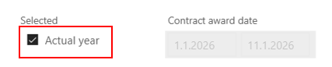
After doing so, you are presented with an option to enter the desired submission dates of the public contract (from – to), by using the calendar which appears after left-clicking on the date field, or by manual entry (right-click on the date field).
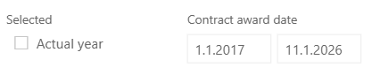
There are other data filters available besides the date.
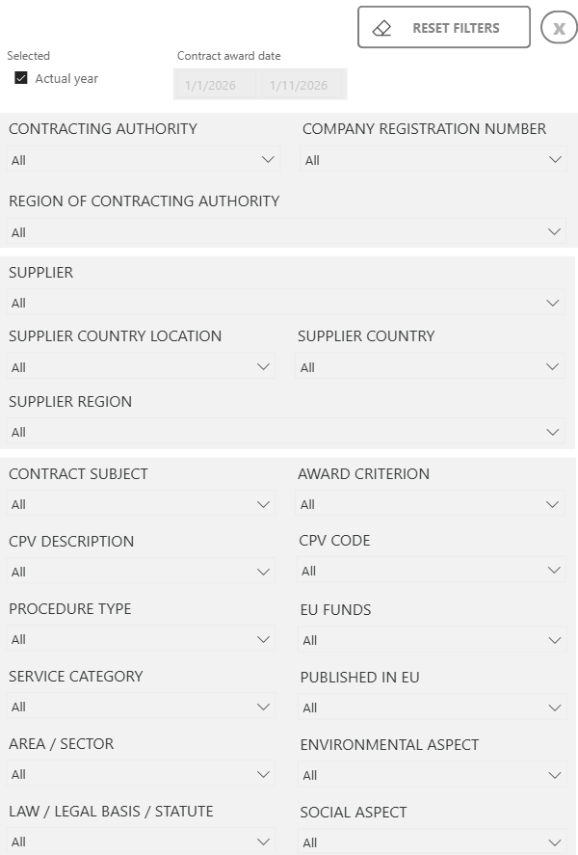

By clicking the downwards arrow right of each filter’s name, a drop-down list opens, where certain values can be entered or selected.
Individual filters can be removed by clicking the eraser.
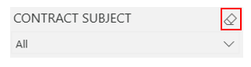
By clicking the “Reset filters” option on the filter page in the upper-right corner, all filters are reset at once. The filter window is closed by clicking the cross (X).
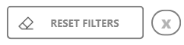

Data interaction
In addition to selecting filters on the filter page, it is also possible to filter data directly on the report, as the objects in the report are interactive and clickable.
Example: Clicking on the “Blago/Goods” (or name or coloured area) value on the object/graph while in the object/graph of “Contract subject”, filters and recalculates the entire report only for the selected order item. The colours of other values (“Storitve/Services”, “Gradnje/Construction”) fade in the report’s object, while the chosen value gains a more noticeable colour.
To unmark the selected “Blago/Goods”, click on “Blago/Goods” again or click on a neutral part of the report, such as the white background in the object.
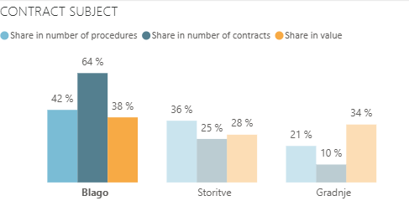

It is possible to filter multiple things at the same time. Multiple filters can be selected simultaneously by holding the CTRL (Control) key and clicking with the mouse.
Example: To filter the whole report by “Blago/Goods” and “Storitve/Services”, first click on the first one and then hold down the CTRL key on the keyboard and click on the second one.
The selection of multiple values is not limited to a single object, but we can also select values of other objects (e.g., area, subject, client) by using the CTRL key. The result in the report is the intersection of all filters we applied by clicking on the values on the objects.

Overview of the selected filters
The current filter selection is visible by placing the mouse on the object. A funnel appears at the top right. Placing the mouse on the funnel shows a list of all filters which affect the display, including filters brought by interactions from other objects.
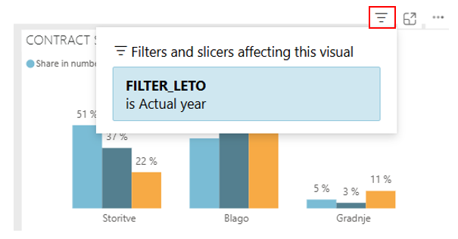
A list of selected filters on the data display is also shown on the bottom right of the report.
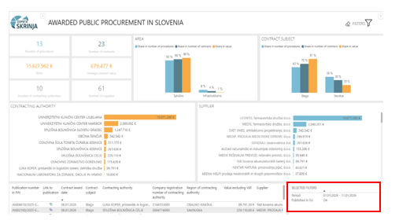

In-cloud tips
Additional information is obtained by placing the mouse on a certain value in the object (e.g. “Splošno/General” in the graph Area). In-cloud tips or additional information included in the object are displayed.
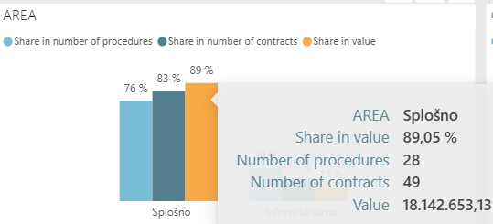

Data export
Each object has the option to export data in .xlsx or .csv formats. By placing the mouse on the object, an option “…” (More options) appears in the upper-right corner. Click on “…” and select the firs option “Export data”. Confirm the selected export method and click on the “Export” button to transfer the file which can be opened with Excel.
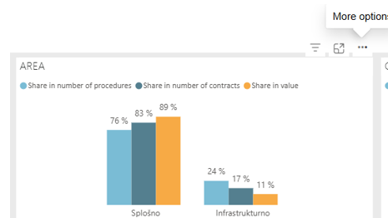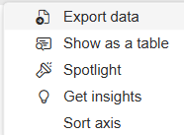
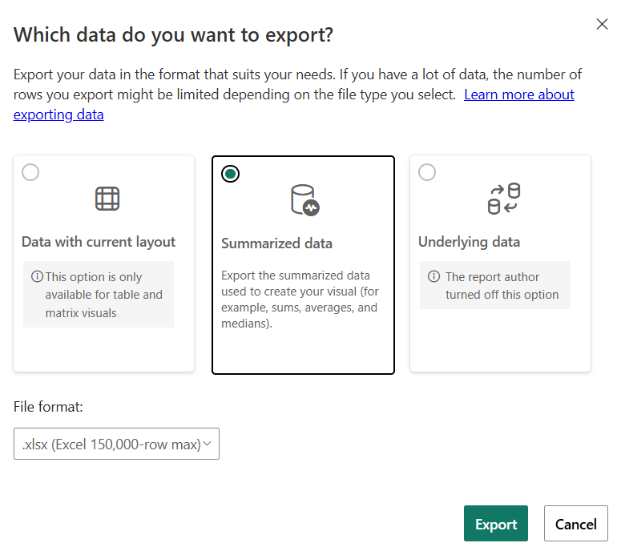

The maximum number of lines which can be exported at once in .xlsx format is 150,000, whereas .csv format allows 30,000.

Other functionalities

Show as a table
Clicking on “…” option in the upper-right on the object and choosing the second option “Show as a table” from the drop-down list, the object expands across the upper half of the screen, and a table appears in the lower half, displaying all the data which appear in the object.
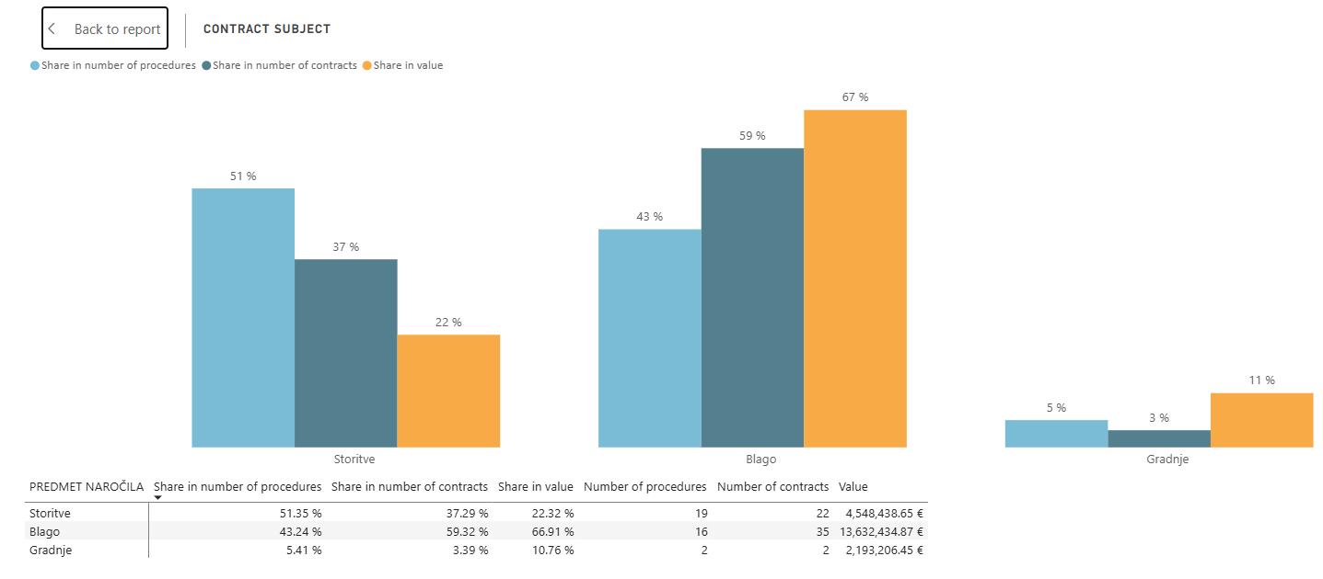
Returning to the report page is possible by clicking the upper-left button “Back to report”.
The option “Show as a table” is similar to exporting to Excel.

Focus mode
When displaying the report, we try to include as much information as possible, which is why some objects (especially on smaller screens) may be difficult to read. There is a focus mode which enlarges the object across the entire screen.
By placing the mouse on the object, a sign »Focus mode« appears in the upper-right corner on the object. Clicking on it expands the object across the entire screen.
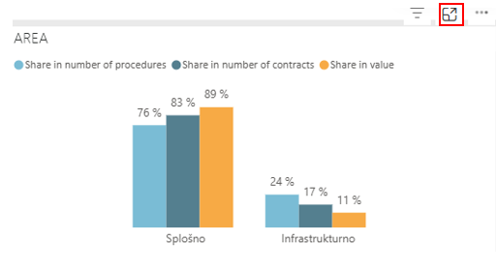
Returning to the report page is possible by clicking the upper-left button “Back to report”.

Data sorting
By clicking on “…” on the upper right corner of the object and choosing the last option “Sort” from the drop-down list, there is an option to sort by all the data included in the object. Sorting is also possible on the filtered data.
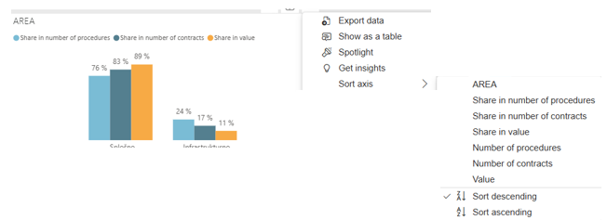

Link to the contract award notice on the Public Procurement Portal
In the list view of public procurement, clicking the paperclip in the column “Link to publication” opens the contract award notice on the Public Procurement Portal.
